Short communication

Broadcast spawning in Porites lutea at Reunion Island (Western Indian Ocean)

L. M. Massé^{1,2*}, Armand Daydé³, Mathieu G. Séré^{3,4}, Florence Trentin³

¹Natural Marine Reserve of Reunion (RNMR), 39 rue du Lagon, 97434 La Saline les Bains
²Research Institute for Development (IRD), UMR-ENTROPIE, 2 rue Joseph Wetzell, 97495 Sainte Clotilde Cedex, La Réunion.
³Vie Océane, Non Gouvernemental Organisation, 16 avenue d’Aquitaine, 97427 Etang Salé les Bains
⁴Aquatic Research Facility, Environmental Sustainability Research Centre, University of Derby, UK, DE22 1GB
* Corresponding author: lola.masse@gmail.com
Key words: coral; spawning; Porites; Reunion Island.
The scleractinian Porites lutea, commonly found on back reefs, lagoon and fringing reefs, is an important reef-building coral in the western Indian Ocean (WIO) reefs. Despite its widespread distribution, little is known on its reproductive capacity to spread its genotype and increase the population. Here, we report in situ observations of broadcast spawning of P. lutea on a shallow reef flat of Reunion Island.
Spawning in P. lutea was observed in January 29th 2016 on the reef flat of Etang Salé (~1m deep, Reunion Island, 21°16’°00”S, 55°19’55”E, Figs.1a,b), five days after the full moon, at 7:30 p.m. Large colonies (>50cm in diameter) of P. lutea were observed releasing simultaneously either sperm or oocyte (Figs. 1a-b). During spawning, oocytes were packed in bundles (Fig 1c) and showed a partially dark pigmentation (Fig. 1d) suggesting the presence of zooxhanthellae in the tissue. Only colonies bordering an artificial channel for small boat circulation were reported spawning this night. An additional night observation was conducted the following day, yet no spawning was observed.
Gonochorism and a similar timing of reproduction were reported previously in P. lutea on the reef flat of la Saline (Planch’Alizé, Réunion Island), where it happened on December 29th 2007, 5 day after the full moon (Denis et al. 2011). This mode and timing of reproduction (December to early February, 2-5 days after the full moon), as well as the presence of zooxanthellae in the occytes are also observed in colonies of P. lutea and P. lobata at similar latitudes (20-23°S) in eastern and western Australia (Kojis and Quinn 1982; Baird et al. 2011; Stoddart et al. 2012). This suggests a consistent pattern of reproduction in Porites spp, in environments exposed to a similar temperature regime. Further study is required to understand the cues of spawning in P. lutea and document its reproductive effort in Reunion Island.

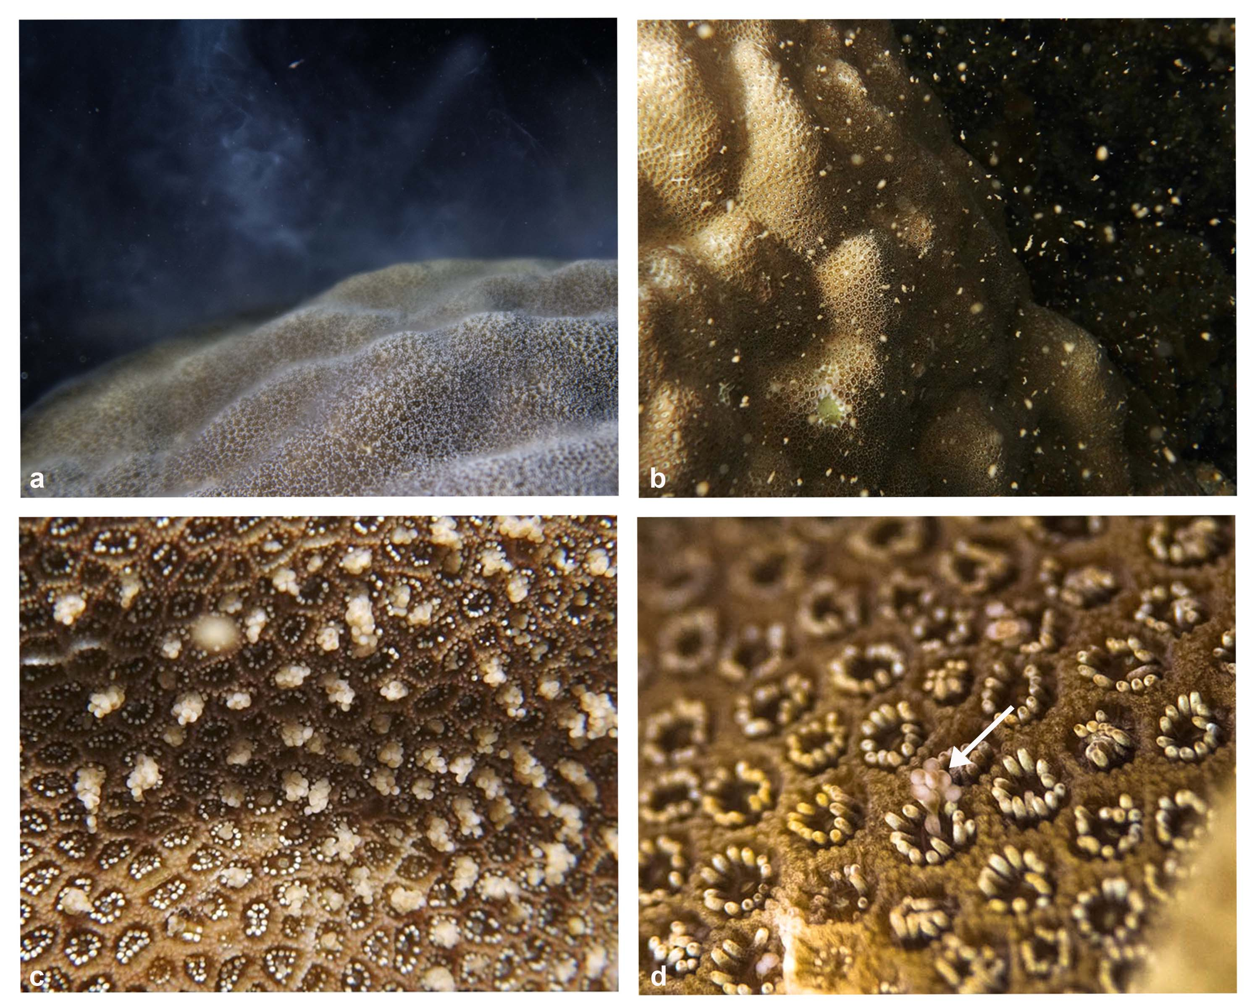

Figure 1: Male (a) and female (b,c,d) colonies of Porites lutea during spawning on the reef flat of Reunion Island in January 2016. In female colonies, oocytes are packed in bundles (c) showing dark green pigmentation (d) probably due to the presence of zooxanthellae in the tissue.
REFERENCES
Baird AH, Blakeway DR, Hurley TJ, Stoddart JA (2011) Seasonality of coral reproduction in the Dampier Archipelago, northern Western Australia. Marine biology 158:275–285.
Denis V, Debreuil J, De Palmas S, Richard J, Guillaume MM, Bruggemann JH (2011) Lesion regeneration capacities in populations of the massive coral Porites lutea at Réunion Island: environmental correlates. Marine Ecology Progress Series 428:105–117.
Kojis B, Quinn N (1982) Reproductive strategies in four scleractinian species of Porites (Scleractinia). Gomez C E, Birkeland R W, Buddemeier R E, Johannes J A, Marsh J and R T Tsuda (eds), Vol. 4, Manila, Philippines, pp 145-151.
Stoddart CW, Stoddart JA, Blakeway DR (2012) Summer spawning of Porites lutea from north-western Australia. Coral Reefs 31:787–792.

