**Supplementary Data for the Article:**

**The status of Mtwapa Creek mangroves as perceived by the local communities.**

Judith Auma Okello*1,2,3, Victor Mwakha Alati3, Sunanda Kodikara2,4, James G. Kairo3, Farid Dahdouh-Guebas1,2 and Nico Koedam1

1Laboratory of Plant Biology and Nature Management (APNA), Vrije Universiteit Brussels,Pleinlaan 2, B-1050 Brussels, Belgium; 2Laboratory of Systems Ecology and Resource Management, Université libre de Bruxelles, Avenue F.D. Roosevelt 50, CPI 264/1, B-1050 Brussels, Belgium; 3Kenya Marine and Fisheries Research Institute (KMFRI), P.O. Box 81651-80100, Mombasa, Kenya; 4Department of Botany, Faculty of Science, University of Ruhuna, Wellamadama, Matara, Sri Lanka

**\*Corresponding author:** Judith A. Okello

Email- [judith_okello2003@yahoo.com](mailto:judith_okello2003@yahoo.com); [jokello@kmfri.co.ke](mailto:jokello@kmfri.co.ke)

Tel.: +254 726 341

**Table S1**: Extraction of mangrove wood products within Kilifi county between the years 1990 and 2012 (Source, Kenya Forest Services Kilifi county, Kenya).



Blanks are missing data as KFS could not account for this. Hyphens are zero values

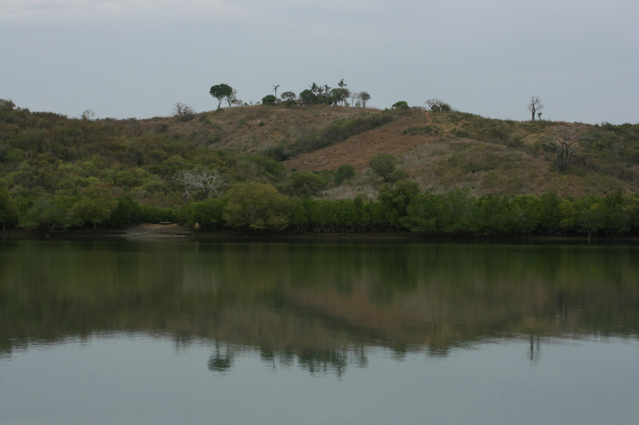

**Supplementary Plate S1:** Some of the agricultural farms seen along Mtwapa Creek on the steep slopes facing the mangrove forest below. (*Picture by Nico Koedam, February 2011*)