Fig. 1 Routes of plague introduction and distribution in Tanzania
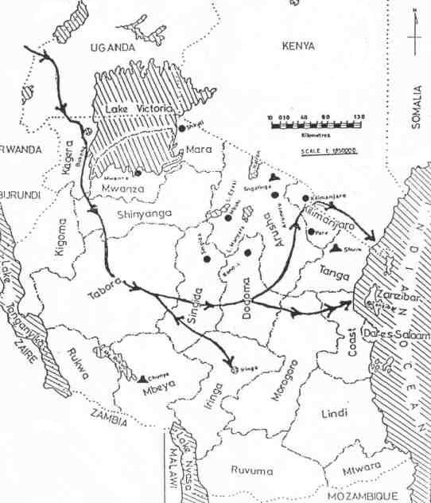

Fig. 2 Distribution of plague in Tanzania
