16 ^{th} June, 2015.
Editor,
Tanzania Journal of Health Research,
E-mail: lmboera@nimr.or.tz

Dear Editor,

Please accept our manuscript, entitled “Health care worker’s perceptions toward quality of health care at outpatient department in Mwananyamala hospital in Dar es Salaam, Tanzania”.
On behalf of my co-author, I would like to submit a manuscript for consideration for publication in your esteem journal.

I qualitative study was conducted in 2013 at Mwananyamala hospital to explore health care worker’s perceptions towards quality of care at outpatient department. A total of 27 health care workers at the outpatient department participated in the study. The results from the study highlighted multiple factors that influence both extrinsic as well as intrinsic motivation of participants towards quality of care.

It is our hope that these findings will assist the hospital administration to address the concerns of their health care workers in order to improve the quality of care at the outpatient department at Mwananyamala hospital.

Both authors have participated in the review of the manuscript, and approved the final version, and can take responsibility for the content of the paper. In addition, we have conform to the Journal’s author guidelines.

No financial conflicts of interest exist in relation to this research that should be disclosed. I testify to the accuracy of the above on behalf of the co-author.
Please do not hesitate to contact the corresponding author: biesein2007@gmail.com if you have any questions or concerns.

It is our hope that you will consider this manuscript, and we look forward to hear from you.
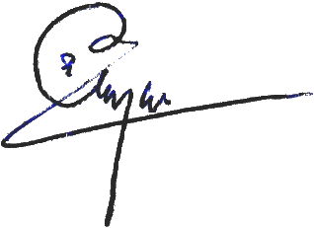
Yours sincerely,

Bernard Njau, M.P.H.
biesein2007 @gmail.com

