ENHANCEMENT OF SUPERCONDUCTIVITY IN LEAD (Pb) BY INTENSIFIED GRAVITATIONAL INTERACTION BETWEEN ELECTRON PAIRS

Tsadik Kidanemariam¹ and Gebregziabher Kahsay²

¹ Department of Physics, Adigrat University, Ethiopia. E-mail: tsadik.k@gmail.com
² Department of Physics, College of Science, Bahir Dar University, Ethiopia

ABSTRACT: This work focuses on the theoretical investigation of the possible enhancement of superconductivity for the superconducting lead (Pb) by intensified gravitational interaction (IGI) between electron pairs. By applying the quantization theory of gravity (QTG), we obtained expressions for the enhanced superconducting transition temperature ($T_{C}$), and superconducting energy gap ($∆$). By using the experimental, theoretical values and some plausible approximations of the parameters in the obtained expressions, the phase diagrams of superconducting energy gap versus temperature for lead at $T_{C}=7.2 K$ and the enhanced superconducting energy gap versus temperature for lead at $T_{C}=178 K$are plotted. By combining the two phase diagrams, we had shown the possible enhancement of the superconducting transition temperature from $T_{C}=7.2 K$to${ T}_{C}=178 K$ and its superconducting energy gap from$2.19 x {10}^{-3} eV$to $5.4 x {10}^{-2} eV$ for the superconducting lead.

Key words/phrases: Cooper pair, lead (Pb), quantization theory of gravity, superconducting energy gap, superconducting transition temperature

INTRODUCTION

Superconductivity is a phenomenon of zero electrical resistance and it was discovered in 1911 by Heike Kamerlingh Onnes while he was studying the resistance of solid mercury at cryogenic temperatures using the recently produced liquid helium as a refrigerant. Onnes observed the abrupt disappearance of the resistance of mercury at a temperature of 4.2 K (Onnes, 1911). In subsequent years, superconductivity was observed in several other materials such as in lead, aluminum, lanthanum, antimony, niobium nitride, niobium titanium (NbTi), magnesium diboride (MgB₂), zirconium nitride (ZrN), niobium tin (Nb₃Sn), niobium germanium (Nb₃Ge), etc.
As is well known, the Bardeen, Cooper and Schrieffer (BCS) microscopic theory of superconductivity (Bardeen et al., 1957) gives a guide for achieving high superconducting transition temperature ($T_{C}$) with no theoretical upper bound; all that is needed is a favorable combination of high-frequency phonons, strong electron–phonon coupling and a high density of states (Drozdov et al., 2015). According to the BCS theory, a lattice distorts as an electron passes by positively charged ions in the lattice of the superconductor. This distortion is due to an attraction of the positive ions of the lattice to the negative electron. A more electrically positive zone will be formed in the distorted area, thus being more attractive to the electron. This attracts a closely available nearby negative electron that will also pass along the relatively positive trough in the distorted lattice area. This second electron is able to follow the path of the first before the crystal lattice bounces back to its original position. This phenomenon brings the two electrons to form pairs, known as Cooper pairs (Cooper, 1956). The paired electron produced in this way is coherent as it passes through the superconductor in unison. The paired electrons in a superconductor condense into a quantum ground state and travel together collectively, coherently and carry electric current in the superconductors.
As a result of some misinterpretations of the BCS theory there was a belief that superconductivity in metals cannot exist at temperatures above 30 K (Mazin, 2015). Recent discoveries demonstrated that, high temperature superconductors can be realized in metals with a favorable combination of parameters (Eremets and Drozdov, 2016). In 2001, the discovery of conventional superconductivity in $MgB_{2}$with T_{C}=39 K (Nagamatsu et al., 2001) which is a phonon-mediated superconductor has arose great interest in the scientific community. Furthermore, the discovery of conventional superconductivity in $H_{3}S$ with $T_{C}=203 K$(Drozdov et al., 2015) turned attention back to the predictions of the BCS theory concerning the room temperature superconductors.
One of the most remarkable features emerging from the BCS theory is the existence of an energy gap$(∆$) between the BCS ground state and the lowest quasi-particle excited state (Tinkham, 1975). This is the minimum energy required to create a single-electron excitation from the superconducting ground state. The BCS theory predicts the dependence of the superconducting energy gap (Δ) on temperature. The ratio between the value of the energy gap at a temperature of 0 K and the value of the superconducting transition temperature (expressed in energy units) takes the universal value (Tinkham, 1975) given by
$∆\left(T=0\right)=1.76 k_{B}T_{C}$, (1)
where $k_{B}$ is the Boltzmann constant and T_{C} is the superconducting transition temperature above which superconductivity is destroyed.
Furthermore, the superconducting energy gap at any temperature _{is} given by (Tinkham, 1996),
$∆\left(T\right)=3.06 k_{B}T_{C}\left(\sqrt{1-\frac{T}{T_{C}}}\right)$. (2)
The energy of the pairing interaction in lead (Pb) superconductor is quite weak and is to the order of${10}^{-3} eV$and thermal energy can easily break the pairs. So, only at low temperatures are a significant number of the electrons in a metal form Cooper pairs. By intensifying the gravitational interaction between electron pairs, we have been able enhance the superconducting energy gap to the order of ${10}^{-2} eV$, which is enough to keep an electron pair at higher temperatures. Thus, metals at higher temperature can have a significant number of electrons in the Cooper pairs which enable them transform such metals into superconductors at higher temperature.

THEORY OF GRAVITATIONAL INTERACTION BETWEEN ELECTRON PAIRS

According to the weak form of the equivalence principle, the gravitational and inertial masses are equivalent. However, the quantization theory of gravity showed that, they are correlated by a dimensionless factor which is different from one. The factor depends on the electromagnetic energy absorbed or emitted by the particle and on the index of refraction of the medium around the particle.
The quantization theory of gravity showed that, the gravitational mass ($m_{g})$and the inertial mass ($m_{i} )$are correlated as follows (De Aquino, 2010).
$χ=\frac{m_{g}}{m_{i}}=\left\{1-2\left[\sqrt{1+{\left(\frac{∆p}{m_{i}c}\right)}^{2}}-1\right]\right\}$, (3)
where$∆p$ is the variation in the particle’s kinetic momentum and is given by $∆p=\frac{h }{λ}$(where h is Planck’s constant and $λ$ is the wavelength of the radiation).
Equation (3) can be expresses as,
$χ=\frac{m_{g}}{m_{i}}=\left\{1-2\left[\sqrt{1+{\left(\frac{λ_{0}}{λ}\right)}^{2}}-1\right]\right\}$, (4)
where$χ$ is the ratio of the gravitational mass and the inertial mass and $λ_{0}$ is the De Broglie wavelength of the particle.
It is easily seen from equation (4) that $m_{g}$cannot be strongly reduced by simply using electromagnetic waves with wavelength,$λ$ . It is a well-known fact that the wavelength of a radiation can be reduced by simply reducing its velocity by making the radiation across a conductive foil. We use oscillating magnetic fields in order to intensify the gravitational interaction between electron pairs in order to produce pair binding energies which is enough to keep them paired at higher temperature. When a body penetrates into a region with a magnetic field in the direction of its central axis, the gravitational mass (m_{g}) of the body decreases progressively. This is due to the increase of the intensity of the magnetic field upon the body while it penetrates the field. The magnetic field used in this case must have extremely-low frequency (ELF).The index of refraction of the material ($n_{r}$) in terms of the relative magnetic permeability$\left(μ_{r}\right)$, electrical conductivity$\left(σ\right)$ and the relative dielectric permittivity ($ε_{r}$) is given by (Quevedo, 1977),
$n_{r}=\sqrt{\frac{ε_{r}μ_{r}}{2}\left(\sqrt{1+{\left(σ/ωε\right)}^{2}}+1\right)}$, (5)
where$ω$is angular velocity and $ε$is the permittivity of the substance.
For superconductors,$σ≫ωε$(De Aquino, 2010), $ω=2πf$ and using $ε_{0}=\frac{ε}{ε_{r}}$, equation (5) becomes,
$n_{r}=\sqrt{\frac{μ_{r}σ}{4πε_{o}f}}$ . (6)
where${ ε}_{0}$ is permittivity of the free space.
Equation (6) shows clearly that, the ELF radiation will strongly reduce the velocity and the wavelength. Thus, the gravitational masses can be strongly reduced by means of extremely-low frequency radiation.
As can be seen in Fig. 1, the modified wavelength ($λ_{mod}$) of the modified wavelength ($λ_{mod}$) of the incident radiation becomes,
${ λ}_{mod}=\sqrt{\frac{4π}{μfσ}}$. (7)

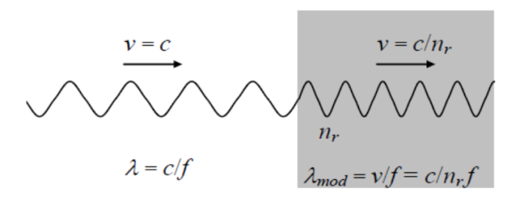

Figure 1. Modified electromagnetic wave. The wavelength of the electromagnetic wave can be strongly reduced, but its frequency remains the same (De Aquino, 2010).

If a lamina with thickness equal to $ξ$contains $n atoms/m^{3}$, then the number of atoms per unit area becomes, $ξn$. Thus, if the electromagnetic radiation with frequency f incident on an area S of the lamina, it reaches $nSξ$atoms. If the incident on the total area of the lamina is, $S_{f}$, then the total number of atoms reached by the radiation is $N=nS_{f}ξ.$ Furthermore, the total number of photons $\left(n_{T}\right)$incident on the lamina is given by, $n_{T}=\frac{P}{hf^{2}}$ , where$P$ is the power of the radiation flux incident on the lamina. When an electromagnetic wave incident on the lamina, it strikes $N_{f}$ front atoms, where $N_{f}≅\left(nS_{f}\right)∅_{m}$and $ϕ_{m}$is the diameter of the atom. Thus, the electromagnetic wave which is incident effectively on an area $S=N_{f}S_{m}$, where $S_{m}=\frac{1}{4}π{ϕ_{m}}^{2}$ is the cross sectional area of one atom. After these collisions, it carries out $n_{c }$ collisions with the other atoms as shown in Fig. 2.
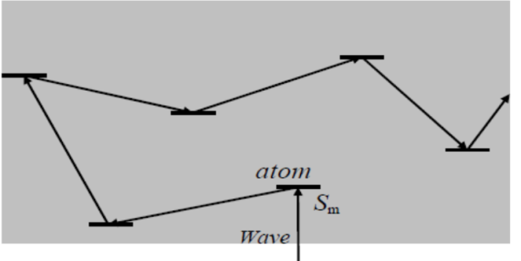

Figure 2. Collisions inside the lamina (De Aquino, 2010).

Thus, the total number of collisions in the volume $Sξ$ is given by,
${ N}_{c }=N_{f }+n_{c}=n_{m }Sξ$. (8)
The power density of the incident (or emitted) radiation$(D)$, on the lamina can be expressed by,
$D=\frac{P}{N_{f }S_{m}}$. (9)
We can express the total mean number of collisions in each atom,${ n}_{l}$, by means of the following equation,
${ n}_{l}=\frac{n_{T}N_{c}}{N}$,
${ n}_{T}N_{c}={Nn}_{l}.$ (10)
Since in each collision a momentum $\frac{h}{λ }$ is transferred to the atom, the total momentum transferred to the lamina will be given by,$∆p=\left(n_{l}N\right)h/λ$.
Substituting equation (10) into equation (3), we get,
$\frac{{ m}_{g(l)}}{ m_{i(l)}}=\left\{1-2\left[\sqrt{1+{\left[n_{T}N_{c}\frac{λ_{0}}{λ}\right]}^{2}}-1\right]\right\},$ (11)
But, $n_{T}N_{c}=\left(\frac{P}{hf^{2}}\right)\left(n_{m }Sξ\right),$ (12)
Thus we get,
$\frac{{ m}_{g\left(l\right)}}{m_{i\left(l\right)}}=\left\{1-2\left[\sqrt{1+{\left[\left(\frac{N_{f }S_{m}D}{f^{2}}\right)\left(\frac{n_{l}Sξ}{m_{io\left(l\right)}c}\right)\frac{1}{λ}\right]}^{2}}-1\right]\right\}$. (13)
Substituting, $N_{f}≅\left(nS_{f}\right)ϕ_{m}$ and $S=N_{f}S_{m}$ into equation (13) yields,
$\frac{ m_{g\left(l\right)}}{ m_{i\left(l\right)}}=\left\{1-2\left[\sqrt{1+{\left[\left(\frac{n^{3}{S_{f}}^{2}{S_{m}}^{2}{ϕ_{m}}^{2}ξD}{m_{io\left(l\right)}cf^{2}}\right)\frac{1}{λ}\right]}^{2}}-1\right]\right\}.$ 14)
The power density (D), for the lamina inside an ELF, with E and B is given by (Halliday et al., 1968),
$D=\frac{n_{r\left(l\right)}E^{2}}{2μ_{0}c}$. (15)
Using equation (15) in equation (14), we obtain,
$\frac{m_{g\left(l\right)}}{m_{i\left(l\right)}}=\left\{1-2\left[\sqrt{1+{\left[\left(\frac{{n_{r\left(l\right)}n}^{3}{S_{f}}^{2}{S_{m}}^{2}{ϕ_{m}}^{2}ξE^{2}}{2μ_{0}m_{i\left(l\right)}c^{2}f^{2}}\right)\frac{1}{λ}\right]}^{2}}-1\right]\right\}$. (16)
Using the knowledge of electrodynamics, the relationship between the electric field and magnetic field is given by $E=vB=\left(c/n_{r\left(l\right)}\right)B$.
Thus, using $λ=\frac{c}{f} ,$equation (16) becomes,
$χ=\frac{m_{g(l)}}{m_{i(l)}}=\left\{1-2\left[\sqrt{1+\frac{n^{6}{S_{f}}^{4}{S_{m}}^{4}{ϕ_{m}}^{4}ξ^{2}B^{4}}{4{μ_{0}}^{2}{m_{i(l)}}^{2}f^{2}c^{2}}}-1\right]\right\}$. (17)
In order to calculate the expressions of $χ_{Be}$ (where $χ_{Be}$ is the ratio of the gravitational mass and the inertial mass due to the electrons inside the magnetic field) for the particular case of a free electron inside a conductor subjected to an external magnetic field (B) with frequency $f$, we must consider the interaction with the positive ions that make up the rigid lattice of the metal. Under these circumstances, the volume of the electron does not vary, but its external surface is increased and becomes equivalent to the external area of a sphere with radius $r_{x}≫r_{e}$(De Aquino, 2010), where, $r_{e}$ is the radius of the free electron out of the ions.
Based on such assumptions, we substitute in equation (17), $n$by$n=\frac{1}{V_{e}}=\frac{1}{\frac{4}{3}π{r_{e}}^{3}},{ S}_{a}$ by${ S}_{m}=π{r_{x}}^{2}$, $ξ$by $ϕ_{m}=2r_{x}$, $m_{i(l)}$ by $m_{e}$, and $S_{f}$ by $S_{f}=\left(SSA_{e}\right)ρ_{e}V_{e}$, where SSAe is the specific surface area for electrons and is given by, $SSA_{e}=\frac{2π{r_{x}}^{2}}{ρ_{e}V_{e}}$.
Therefore, equation (17) becomes,
$χ_{Be}=\left\{1-2\left[\sqrt{1+\frac{45.56 π^{2}{r_{x}}^{22}B^{4}}{c^{2}{μ_{0}}^{2}{m_{e}}^{2}{{r_{e}}^{18}f}^{2}}}-1\right]\right\}$. (18)
From the wave packet that describes the electron,$r_{x}$ is approximated to $λ_{0}$ and has a value,$r_{x}≅2.43 x {10}^{-12} m$. Now using the geometrical radius of electron, $r_{e}=6.87 x{10}^{-14} m$ and substituting the values of the constants into equation (18) gives,
$χ_{Be}=\left\{1-2\left[\sqrt{1+1.2 x {10}^{38}\frac{B^{4}}{f^{2}}}-1\right]\right\}.$ (19)
Similarly, in the case of a proton with radius,${ r}_{p}=0.85 x {10}^{-15} m$, we have,
$χ_{Bp}=\left\{1-2\left[\sqrt{1+2.35 x {10}^{-9}\frac{B^{4}}{f^{2}}}-1\right]\right\}$. (20)
It is easy to see from equations (19) and (20) that, the gravitational mass of the electron $\left(m_{ge}\right)$ is much greater than the gravitational mass of the proton$(m_{gp})$. This means that, we can ignore the effects of the gravitational masses by the positively charged ions on the electrons.
Therefore, the expression for the gravitational forces between the two electrons reduce to,
$F_{g}=-G\frac{{m_{ge}}^{2}}{r^{2}}=-{χ_{e}}^{2}G\frac{{m_{e}}^{2}}{r^{2}}.$ (21)
For the creation of the Cooper pairs,$F_{g(attraction)}$ must overcome the electrons' repulsion force ($F_{repulsion}$) due to their negative charges.
Thus, we have,
$${ F}_{g(attraction)}>F_{repulsion},$$

${{-χ}_{Be}}^{2}G\frac{{m_{e}}^{2}}{r^{2}}>\frac{e^{2}}{4πε_{0}r^{2}}$,
$χ_{Be}<-\frac{\left(\frac{e}{m_{e}}\right)}{\sqrt{4πε_{0}G}}<2 x {10}^{21}.$ (22)
For the Cooper pairs not to be destructed by the thermal vibrations due to the temperature, we must have,
$\frac{{χ_{Be}}^{2}G{m_{e}}^{2}}{r}>k_{B}T$.
Consequently, the superconducting transition temperature, at $r=ξ$ can be expressed by the following expression,
${ T}_{C}<\frac{{χ_{Be}}^{2}G{m_{e}}^{2}}{k_{B}ξ}$, (23)
where the distance between the two electrons of the Cooper pair in lead superconductor is $ξ≅9 x{10}^{-8} m$ (Donnelly, 1981) at T = 0 K.
Hence, the superconducting transition temperature of lead metal for${ χ}_{Be}<2 x {10}^{21}$ will be,
${ T}_{C}≤178 K.$ (24)
Using equation (19), the intensity of the magnetic field (B) with frequency $f=1 Hz$, which is necessary to produce the value given by equation (24) must have a value of,
$B≅9.5 Tesla$ (25)
Now let us consider lead superconductor. Since lead is a conventional superconducting material, the pairing mechanism between the electrons of lead is mediated by phonons. The experimentally observed superconducting transition temperature for lead is $T_{C}=7.2 K$(Matthias et al., 1963). Thus, the superconducting energy gap extrapolated to the absolute zero temperature is given by,
$E_{g}=2∆\left(0\right)=3.53 k_{B}T_{C}$,
$E_{g}=2.19 x {10}^{-3} eV.$ (26)
Using $T_{C}=178 K,$ the enhanced superconducting energy gap of lead superconductor becomes,
$E_{g}=2∆(0)=3.53{ k}_{B}T_{c}$,
From which we get,
$E_{g}=5.4 x {10}^{-2} eV.$ (27)

RESULTS AND DISCUSSION

By using equation (2) and considering some plausible approximations, the phase diagram for the dependence of the superconducting energy gap on temperature is plotted as shown in Fig. 3. As can be seen from the figure, the temperature dependence of superconducting energy gap for lead decreases as the temperature increases and vanishes at$T_{C}=7.2 K.$
Furthermore, we plotted the phased diagram for the variation of the enhanced superconducting energy gap with temperature using the enhanced superconducting transition temperature as shown in Fig. 4. As can be seen from the figure, the value of the enhanced superconducting energy gap at absolute zero temperature is $5.4 x {10}^{-2} eV$ and decreases as temperature increases and vanishes at the enhanced superconducting transition temperature, $T_{C}=178 K$ for lead superconductor.
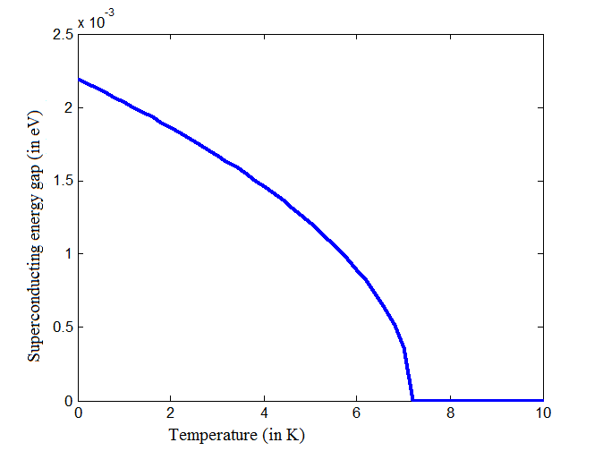
Figure 3. Superconducting energy gap (eV) versus temperature (K) for superconducting lead.

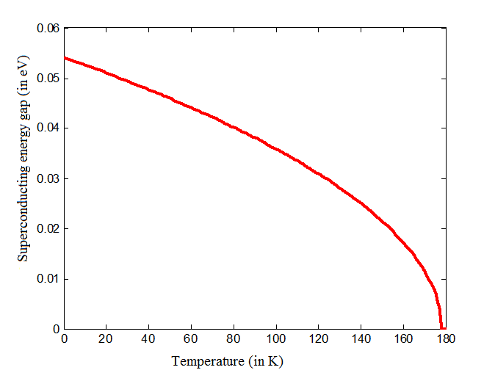

Figure 4. Superconducting energy gap (eV) versus temperature (K) for the enhanced superconducting transition temperature for lead.

Now, by merging Figures 3 and 4, we demonstrated the enhanced superconducting region for superconducting energy gap and superconducting transition temperature as shown in Fig. 5 for lead superconductor.
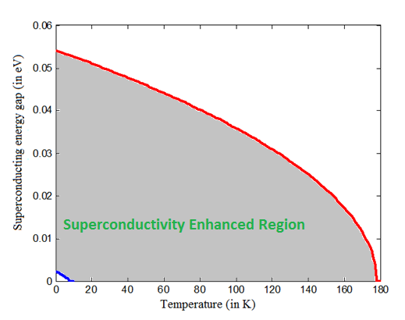
Figure 5. Enhancement of superconductivity in lead by intensifying the gravitational interaction between electron pairs.
CONCLUSION

Finally, we conclude that, by intensifying the gravitational interaction between electron pairs, it is possible to enhance the superconducting transition temperature (T_{C}) of lead from 7.2 K to 178 K and the superconducting energy gap from $2.19 x {10}^{-3} eV$ to $5.4 x {10}^{-2} eV.$Therefore, if a magnetic field with frequency $f=1 Hz$ and intensity $B≤9.5 Tesla$ is applied upon the superconducting lead, then it becomes a superconductor at a superconducting transition temperature of$,T_{C}=178 K$.

REFERENCES

1. Bardeen, J., Cooper, L. N. and Schrieffer. J. R. (1957). Theory of superconductivity. Phys. Rev., 108 (5):1175-1204.
2. Cooper, L. N. (1956). Bound Electron Pairs in a Degenerate Fermi Gas. Phys. Rev., 104:1189-1190.
3. De Aquino, F. (2010). Mathematical Foundations of the Relativistic Theory of Quantum Gravity. Pacific Journal of Science and Technology, 11:173-232.
4. Donnelly, R. J. (1999). Cryogenics fluid daynamics. Journal of Physics: Condensed matter, 11(40): 7783-7834.
5. Drozdov, A. P., Eremets, M. I, Troyan, I. A., Ksenofontov, V., and Shylin, S.I. (2015). Conventional superconductivity at 203 K at high pressures in the sulfur hydride system. Nature, 525:73–76.
6. Eremets, M. I. and Drozdov, A. P. (2016). High-temperature conventional superconductivity. Physics-Uspekhi, 59(11): 1154-1160.
7. Halliday, D. and Resnick, R. (1968). Physics, J. Willey & Sons, Ed. USP, p.1124.
8. Matthias, B. T., Geballe, T. H., and Compton, V. B. (1963). Superconductivity. Reviews of Modern Physics. 35:1-22.
9. Mazin, I.I. (2015). Superconductivity: Extraordinarily conventional. Nature. 525(7567): 40-41.
10. Nagamatsu, J., Nakagawa, N., Muranaka, T., Zenitani,Y. and Akimitsu, J. (2001). Superconductivity at 39 K in magnesium diboride. Nature, 410(6824): 63-64.
11. Onnes, H. (1911). Theory of High Temperature Superconductivity. Akad. V. Wetenschappen (Amsterdam) 14: 113.
12. Quevedo, C. P. (1977). Eletromagnetismo, McGraw- Hill, p. 270.
13. Tinkham, M. (1975). Introduction to Superconductivity. McGraw-Hill, New York: International series in pure and applied physics, p. 296

