THE PERFORMANCE PRACTICE IN AYELE MUSIC AND DANCE OF UNUWAZI-UROMI, EDO STATE, NIGERIA

ALUEDE ESTHER OMONE
&
ALUEDE, CHARLES ONOMUDO
Ambrose Alli University, Ekpoma, Edo State-Nigeria.

ABSTRACT
This paper focuses on Ayele music and dance of the Unuwazi village in Uromi, Esan North East Local Government Area of Edo State. It examines the term Ayele, its tradition of origin, its musical instruments, context of performance and performance practices. So as to be able to elicit data from the field, ethnographic method was employed. This entails the observation, interview and focused group discussion techniques. Other relevant secondary data were sourced from the libraries and the internet. This study reveals that Ayele music is unique in that it is purely instrumental musical genre that has not been influenced by modern day forces of acculturation. It is a social/ritual musical genre whose performance is regulated by a number of factors. This presentation is germane in that it provides a new oeuvre, ritual music even in this twenty-first century epoch, and epitomizes the fact that music in Africa is not simply for the purpose of entertainment.
INTRODUCTION
Without doubt, music making in Africa is an integral component of community life and it is of much value. This value is not just because of the entertainment it provides but more so, it’s integrative attributes. Through music making, individuals of different age grades are found performing together in an organically unified form for the overall improved quality of performance. Through music, the mores of a people are perpetuated and safeguarded from all the forces threatening it. Ayele music is a special kind of music which is performed by the Unuwazi people of Uromi, Edo State of Nigeria. In the whole of Esan in Edo North Senatorial District, no other town or village performs it. Although Ayele music and dance is a ritualistic one, it has been observed that the genre is ethnographically under-documented in spite of its place at the kings’ and Oba’s palaces and in the cultural settings. This ensemble has highly restricted context of performance and its audience spectatorship is regulated. Granted this present status, much of its activities are shrouded in mysteries and obscurities. Not much is today known of its origin, avenues of performances, performance practices, ensemble composition and the musical instruments used in this ensemble. It is as a result of these issues raised above that this study seeks to: Examine the term Ayele, Study the ensemble’s composition, context of performance, identify the musical instruments used and evaluate the level of its acceptability in the society
While aiming at the general preservation of the Ayele repertory involving both field and desk work, information were gathered through personal experience, direct observation, independent investigation and oral interviews from the leaders of Ayele group, it is contended that in the era of globalization, this work will contribute to the general corpus of works on traditional music in Nigeria and the world at large.
A HISTORICAL OVERVIEW OF UROMI IN ESAN
Uromi kingdom is one of the thirty-two towns in Esan. It is the current local government headquarters of Esan North East Local Government in Edo State. On its origin, Ojeifoh (2002:2), upholds that:
The first settlers at Uromi emigrated to Uromi at about 1025 AD after the death of the king Ogiso Ere. There was said to be an epidemic in the land during the reign of Ogiso Orire-the outbreak of small pox that claimed many homes. The soothsayers were said to have consulted their oracle and the result was that some people who are wizard and witches were responsible for the epidemic. Many people died through ordeals to determine whether they were witches. The few that escaped from the village went into the jungle and wandered far away from the cruel laws of the Ogiso. They later came to the table land now known and called Urobhum (Uromi is the anglicized version of Urobhun).
The much that is known of the origin of Esan is based on oral tradition. No one can say with certainty how this people evolved. Today, the origin of Esan is a subject of scholarly investigation by cultural historians, cultural anthropologists, traditionalists and linguists (Aluede, 2010). Ab initio, Egharevba (1968:84) remarked that “the early people of Esan or Ishan were Bini emigrants from the first and second periods of the Bini Empire. Esan is the name of the first man who migrated from the city of Benin and became the founder, the progenitor of Esan”. From records, the origin of Esan is traceable to Benin. Hence they are known to be of Edoid extraction. Linguistically, Okpoko and Agbontaen (1993), opine that the Edo language group to which Esan and Bini languages belong is acclaimed to belong to the Kwa language family of the Niger-Congo stock. Till date, Esan is believed to have originated from the Bini Kingdom.

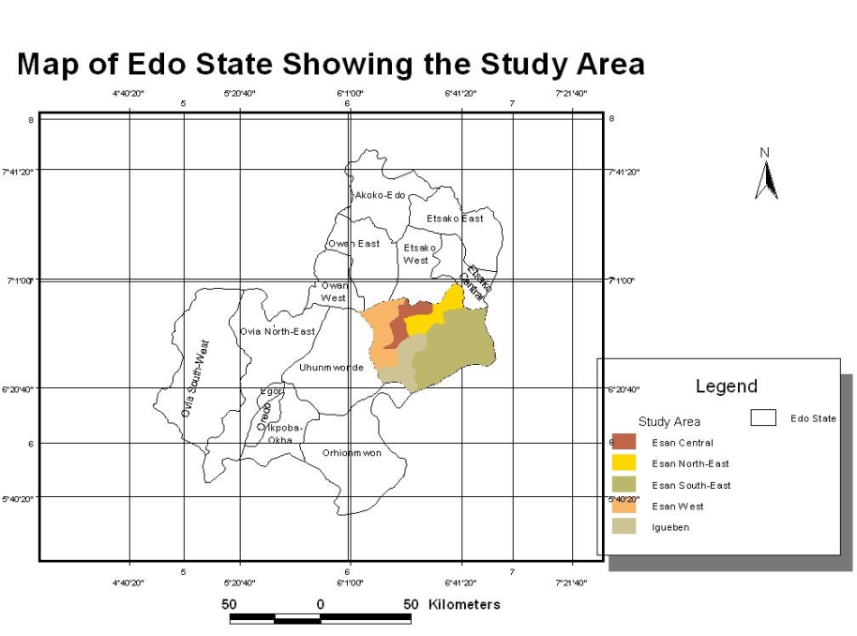
MUSIC IN ESAN
It is not practically possible to imagine the celebration of a major event in traditional African societies without music. While talking specifically of the Igbo community in Nigeria, Echezona (1965:40) remarked that “no event happens that is not associated with music”. Explaining further, he spelt out some of the avenues of music making to include communal labour, war, teaching and learning. There are different kinds of music and musical ensembles in Esan. For example Agu (1990:49), summarized the primacy of music in Igbo culture thus:
Music serves not only as a medium for entertainment and social relationship but as an intricate part of development of the mind; body and soul. It is assumed that the laws of the land are learnt through songs. The history of the tribe is learnt through songs and accepted behavioral patterns in the society are assimilated through music and dance. As a result, the belief strongly existed in the past that no Igbo escaped active participation in musical performances in all ramifications.
In Esan, musical ensembles are many and some of them are: Ujie, Ohoko, Igbabonelimin, Asonogun, Ijieleghe, Ikoghe and Ukpukpe Ayele, Agbenojie to mention a few. Not all of these musical ensembles are performed for the proletariat. This is so because they have their specific or prescribed scope of performances. For example, in some Esan communities, the Agbenojie is strictly for the kings, Ayele for the Oba of Benin, Uromi monarch, High chiefs and dead members of the ensemble and Ukpukpe for the aged women who were elevated to the status of men while alive. Music making in Esan is calibrated in such a manner that who plays it and who listens to it are properly spelt out.
WHAT IS AYELE?
Put simply, Ayele means remembrance. Ayele in the context of Esan musicality means, a performance to be remembered. This is so because the dance can never be forgotten in major celebrations by monarchs and notable personages in the community. The universality of music is well attested to by its much involvement in not just everyday use but for prescribed occasions which also go with prescribed musical types. These occasions range from social to strictly religious events. According to Roberts (1973:8),
The very close relationship between music and social religious life has had a number of effects on the music itself. The concept of music as a purely aesthetic experience is foreign to Africa. … Africans and Europeans judge music differently. In Africa, music is not so much “good” as “effective,” that is, right for its purpose. Thus Francis Bebey says of singing: African voices are… what the total nature of music demands of them: clear to sing of the bride newly brought into the community, hushed to sing of something which one would have preferred to keep quiet, mocking in satire…harsh or soft piercing or tender depending on the time and place.
From the opinion above, one can easily decipher that music is not just for entertainment but has functional undertones. And that these functions are the reason for the content, context and type of any performance.
Looking at yet another critical aspect of African musicianship, Agordoh (1985) added that among the Ankole of Uganda, there is a sacred drum called Bagyendancoa and there is a special cult built around it. He said further that the Lovedu of Transvaal in the Republic of South Africa also have sacred drum; they are said to be four in number, and the smallest of them mystically linked with the life of the queen and the welfare of the state. Similarly, the Bambara ancestral Pantheon are the Tabele drum and Agoni (harp). He further observed that the head of the Ashanti nation has about a dozen or more different instrumental ensembles whose physical and numerical sizes cannot and should not be equaled by any other chief in Ashanti and certain drums are set aside as tribunal drums for summoning councilors to the court.
Agordoh’s observation takes us to the theoretical /philosophical foundation of the reasons why certain instruments are named after deities and monarchs in African nations. This situation was aptly captured by Euba (1986), when he stated that in many African societies, the concept of divine kinship is practiced and kings are considered as second in command to the gods. It is not surprising then that music is very prominent in the activities of kings. On special occasions such as festivals, coronation of kings or chiefs, music is one of the principal means of celebration. He further observed that in many cases, special instruments or ensembles are identified with kingship or chieftaincy and these instruments may not be used or owned by ordinary citizens. In Africa, trumpets and ivory bones are generally regarded as symbols of kingship. Ayele music which is our primary concern falls within this ambit of music for a reigning monarch
HISTORICAL BACKGROUND OF AYELE ENSEMBLE
While narrating the origin of Ayele dance, Oamen says, “there once lived a man called ‘Ugue’. The actual home of this man cannot be remembered, but it was generally believed that he migrated from Ife to Benin. It was while in Benin, he studied bronze work, so he was a bronze smith. He left Benin after he had studied bronze work and came to Era nearly six miles from Ekpoma. In this land there was a big forest with many big trees which had buttresses. On these trees lived monkeys of numerous kinds.
One day this bronze smith went to the bush to collect wood which he could burn to get charcoal for his smith work. As he was in the bush, he heard strange and loud music in another part of the same forest. He tiptoed to the area where he heard the music. When he was some distance to the spot, he saw a big gorilla beating the buttress of a big tree. Other monkeys were beating short logs. Each of these monkeys was knocking pegs against the trees. Other monkeys were dancing round the tree displaying various styles. After watching for a long while, the man went back home.
On getting home, he called his relatives together and told them what he saw. Many of his relatives followed Ugue to the bush in the following day. These men actually saw the scene and so when they got home, they made the arrangement to practice this music in an improved form. They planned to be having the practice every night. Till today the dance must first be performed at night before the real performance is held in the day.
The other people who were not lucky to join them went to report to the Onojie about the strange dance. They had thought that the Onojie would punish them. Contrarily, the then Onojie then called for its performance in his palace.
After the performance the Onojie was so impressed that he compensated the dancers with a cow and fed them. The Onojie notified the Oba of Benin of the dance who also invited them to perform before him; he too was impressed and made stringent law that such a dance should not be performed at any other places than those of the Oba, Onojie and the seven pronounced chiefs on special permission from the Onojie of Uromi. Since then the Ayele dance had been known and called court music.
AYELE MUSICAL ENSEMBLE COMPOSITION IN UROMI
The membership of the Ayele ensemble is strictly restricted to Unuwazi community in Uromi Esan North East Local Government Area in Edo State. Ayele music dance is a community property which is held in a very high esteem not only by the Unuwazi community but by the entire people in Edo State. Unuwazi village is made up of two classes of people and they are; the community of native doctors and the others who are not. Those who are not, are known to be worshippers of iron (Idigun). This, of course, explains why native doctors musical instruments, Ekedeobo and blacksmiths instruments bells are the instrumental resources employed in Ayele ensemble. This ensemble is made of up of elderly men, adult men, boys and girls. The boys, girls and adult men are primarily the dancers, while some of the elderly men play some of the instruments and others being the custodians of the art sit and watch the dance performed in strict sense, and some of the elders are seasoned native doctors who are in charge of spiritual protection of the dancers in performance and prevention of danger during performance.
CONTEXT OF AYELE PERFORMANCE
Without doubt, musical performances have specified avenues for their performance in Africa. For example, Hampton (1992:137) observed that “Adowa is Ga funeral music performed by women (in Ghana)”. According to Omolo- Ongati (2009:16) context of performance of a dance refers to “the why” of the dance which dictates what the dancers do, how, where and when they do it. Context provides the meaning of the dance, frame and environment of the dance based on culturally stipulated rules or expectations. Ayele music and dance ensemble performances are strictly restricted to the Oba of Benin, the Onojie of Uromi palaces and their cabinets. This ensemble is used during the installation of the Oba of Benin, the Onojie of Uromi, coronation ceremonies, burial ceremonies and final burial ceremonies of the chiefs and any other important activity at the palaces. Ayele is always the last ensemble to perform. It is used to close all the events in the palaces after which the Oba or king and their cabinets leave the stage or venue. After its performance, it is a taboo for any other group to perform. History has it that once upon a time, In a bid to underrate this ensemble, members of the musical group that accepted to take their position in the palace started to die in quick succession. That is why till date no other village apart from Unuwazi performs the court music (Okebhole, 2013).
RECRUITMENT AND REHEARSAL HABITS IN AYELE ENSEMBLE
This musical ensemble’s rehearsals take place every first Edeze (native Sunday i.e Eke in Igbo) of the month at the leader’s courtyard at night. These rehearsals usually hold for a maximum of three hours. It is during this period new entrants are recruited and groomed. A minimum of at least two weeks is normally given to Ayele ensemble as a notification or invitation to perform. This invitation goes with the presentation of prescribed kola nuts and a bottle of hot drink. These items are subject to review from time to time, depending on who is inviting and the proximity to the performance location. As soon as agreement is reached, rehearsals will now be everyday affair. It is usually during such rehearsals that the best dancers are selected for the outing (Oamen, 2013). The training style is basically by imitation, while talking of a similar situation in Ghana, Hampton (1992:136) captures a scenario thus:
Adaawe performers learn their skills by imitating adult women outside the circle during performance. Upon reaching adulthood, they join the circle. Their performances are usually not remunerative. They sustain themselves with traditional occupational skills that earn low to moderate incomes. A few are school leavers.
PROCEDURES IN THE ENSEMBLE PERFOMANCE
Earlier in this study, it was observed, that the performers of this genre are either native doctors’ children or children of devotees of iron worshippers (Idigun). This dance in itself has some degree of mysticism in it. Ayele music and dance is not performed in the day without a penultimate night performance. The night performance is the precursor of the day’s own. As earlier mentioned, Ayele musical performance is not a-one day affair. There is normally night performance by the master drummer and very few members in the ensemble where prescribed items required by the ensemble members are provided before the next day’s performance. There are quite a number of reasons for this development which is not accommodated in this study but could be a proposal for future investigation.
During the day light performance, the group comes before the elders at the leader’s house where they will perform briefly while the elders pray for them with cola nut, pour some quantity of gin libation and bless them and the land with a mixture of native chalk and salt. After which they move to the four junctions in their community to dance, then to their ancestral shrine where they also dance round three times before heading to the venue of performance.
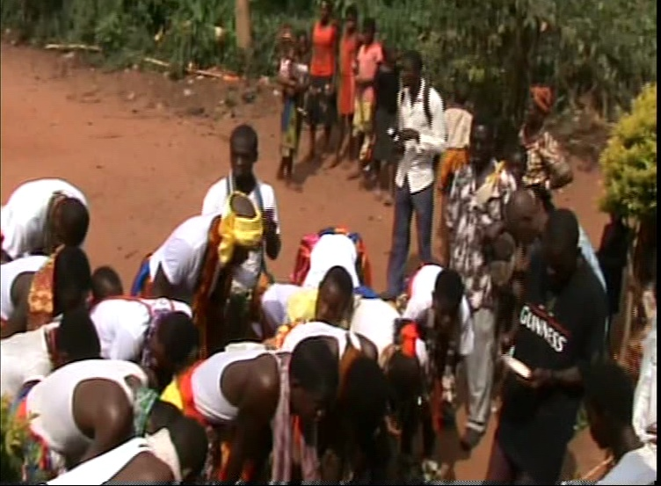
A photograph showing Ayele performers being spiritually fortified for the performance.
PERFORMANCE SITUATION
The purpose of dance performance in Africa varies from one culture to another. Every dance performance in Esan culture is about something and it is the intention that determines how the performance will look like. All dances in this culture are context bound.
Supporting this claim, Paschal (2012), opines that movement to music during an African performance experience may have different outcome for different people depending on who is performing, where they are performing, why they are performing and when they are performing. On the arrival of this musical ensemble at the palace, they move straight to where they have been shown previously and there they will be offered with food and drinks. No serious stage setting is required for this ensemble. Being the last dance at the palace to perform, it closes all events, these musicians stay and watch other performances till it is their turn to perform. During performance, the dancers come into the arena in a linear form, that is, in a single file on the instruction of the Ekedeobo (native doctors drum) as the rhythms of the drums change, the dance formation changes to circular form. They now form a circle in a choreographed dance steps. As the drum sound directs. They dance backwards and forward turn round on a spot and maintain the circle. At the beginning, each danceable movement starts slowly but gradually increases in tempo and intensity as the drum directs.
As upheld by Imolele (2013), the audience maintains a distance from the dance performance being a ritual one. But some of the chiefs could come out when thrilled to appreciate them by giving cash gifts but they must not join in dancing. This money that is sprayed to the dancers must not be picked until they round up the dance.
There are always eye contacts between the dancers and the master drummer. Through this, they are able to read and change dancing styles when necessary. The master drummer controls and directs every step and movement the dancers make with the patterns he plays.
DANCE STYLES AND MOVEMENTS IN AYELE ENSEMBLE
The dance styles and movements are formalized and expressive which is marked by concentrated action and uniformity of movements. The group adopts linear formation in their style. They enter the stage in a single file, and immediately change to circular formation; they form a circle and start to dance round stamping their feet adored with rattles made of dry shells and nuts which give rattling rhythms. Occasionally, they raise up their handkerchiefs to show uniformity in their dance. There is always a native doctor sitting with the instrumentalists who performs some magical acts such as prevention of rain during performance and the fortification of members from unpleasant occurrences during performance.
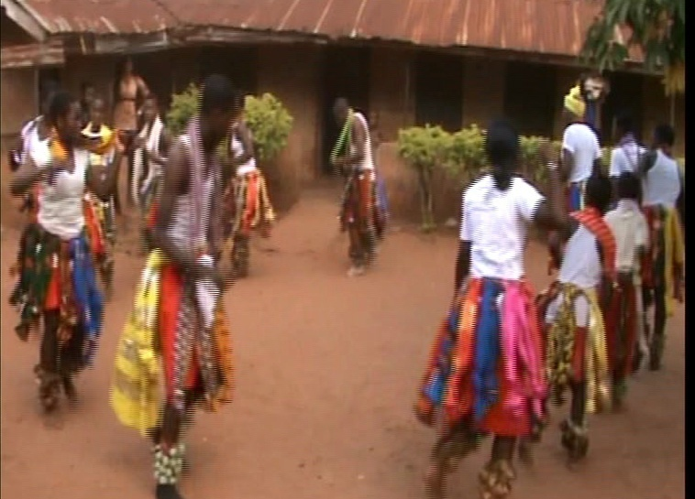
Ayele dancers in circular formation during performance

AYELE INSTRUMENTS AND THEIR CARE.
According Agu (2003:58), “musical groups do not simply go for any musical instruments they fancy rather; there is usually a conscious and careful selection of instruments to suit the orientation of each group”. Similarly, Onwuka (2011) says, “instrumentation is the artistic concept of constituting and arranging various musical instruments for creative musical performances in a given culture”. Ayele music being a ritualistic one, makes use of one native doctors’ double headed drum, one single headed drum two bells, and buzzers. In a performance situation, these instruments are normally played by men in a sitting position.
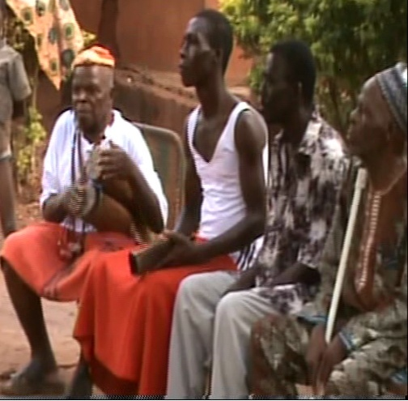
A cross section of Ayele instrumentalists
The single headed drum is played by the most elderly man in the group which establishes the instrumental background for other instruments to follow. This performance does not entail any singing, it is purely instrumental. An important aspect of the sacred nature of the instruments is clearly seen when it is performed outside the palaces, on return, the instruments are purified with a chick. The head of the chick is yanked off and its blood used by a virgin girl of about eight years old who must be a princess to smear/cleanse the instruments. Because it is believed that the instruments have been defiled. In Onuwazi community, Ayele music and dance constitute very serious and important part of their way of life. Every member in the community is known for the love of this music and dance.
COSTUMES
Oxford Advanced Learners Dictionary defines costumes as clothes worn by actors to make them look like something else. In Ayele ensemble, the instrumentalists wear red skirt and white polo on top but the master drummer adds a cap to his own. Each dancer wears buzzers on either or both legs. Their costumes are predominantly red waist turban along with some head ties artistically arranged on top of the shirts and white top.
TABOOS ASSOCIATED WITH THE ENSEMBLE
The instruments are regarded as sacred and should not be touched or played by any woman. Once the dance is in progress or after its performance, no other dance is allowed in the palace. While in performance, it is the Oniha (second to the king in status) or Onojie (the king) that has the right to stop them. It is a taboo for anybody in the audience except the king and his cabinets to participate in the dance. It is a serious taboo for a woman in Unuwazi community who has gone elsewhere to marry to teach the dance to her community members where she is married.
CONCLUSION AND REMARKS
In this presentation, we have examined the term Ayele, investigated how, when, and why this musical genre came into existence, and studied the ensemble’s composition and context of performance. Beyond these, its performance practice, rehearsal habits, musical instruments used in the ensemble and the relationship between audience and performers in the performance were also investigated. It was however observed that some of the informants were averse to divulging some information for fear of rendering every one prone to their highly treasured arts of the community. In a bid to jealously protect music in Africa, certain rules have been put in place which of course is battling for the soul of what is supposedly being protected. Any art that is not propagated is heading towards asphyxiation. Much earlier, Omibiyi (1992:41), remarked that:
Given the diversity of African music, learners should necessarily be introduced first to the music of their ethnic group, then that of other ethnic groups in their countries and finally the music of other African groups as a whole. The knowledge thus acquired will form a strong basis for learning about other musical cultures of the world.
If the desired knowledge of any music is hermetically kept by elders who are dying out without bequeathing their knowledge, then there is the incipient danger of losing treasured arts to unexplained high handedness. Important ensembles of this kind ought to be kept alive. It is this shielding that has often given rise to misrepresentations of African arts. This has given room for misconceptions of the nature and relationship of African music traditions. This misconception is not only generated by the culture carriers but outsiders who perhaps are using their backgrounds to assess the people’s music. For example, Africans have penchant for silence on matters closely related to them and this is does not aid data collection. Hampton (1992:137), succinctly captured the African response to private or personal issues when he threw a question to the Ghanaian princess, Naa Djama on the number of siblings she has, and a polite answer was simply given: “a king has many children”. These general attitudes, coupled with so many taboos are responsible for the dearth of literature in African musical studies.
REFERENCES
Agu, D. C. C. (1990). The Primacy of Music in Igbo Traditional Religion. In E.C.Ekpunobi and I.Ezeagu (Eds) Socio philosophical perspective of African Traditional Religion.49-55. Onitsha: New Age.
Agu, D. C. C. (2003). Music in Nigerian Cultures: Types and Practices In G.C.Unachukwu & G. Okafor (Eds) Nigerian Peoples and Culture. Enugu:John Jacobs Classic Publishers.
Aluede, C.O. (1996). Ijieleghe: Music and Dance of the Esan. An M.A. Thesis submitted to the University of Ibadan.
Aluede, C.O. (2010). Music as Therapy by The Iyayi Society of Edo State, Nigeria. Berlin-Germany: Vdm-publish
Echezona, W. W. C. (1965). Igbo Music in Nigeria. Nigeria Magazine (84), 44-52.
Egharevba, J.U. (1968). A Short History of Benin. Ibadan: Ibadan University Press.
Hampton, B.L. (1992). “Music and Gender in Ga Society: Adawe Song Poetry’ in Contemporary African Music” In African Musicology: Current Trends J.C. Djedje (Ed) Los Angelis: University of California. 135-150.
Iseghohi, E.O. (1991). Music at the Court of the Onojie of Uromi. A B.A. project submitted to Bendel State University, Abraka, Campus.
Ojiefoh, A.P. (2002). Uromi Chronicles 1025-2002. Uromi: Aregbeyeguale Publishers.
Onwuka, U. A. (2011). The Social-cultural Implications of Awuka and Egedege Dances of Aguluezechukwu and Unubi Communities: A Comparative Study. A Doctoral Dissertation submitted to the Department of Music, Nnamdi Azikiwe University, Awka.
Okpoka, A.I. & Agbontaen,K.A. (1993). “ Edo Traditions of Origin”. Some Nigerian Peoples.In Andah, B.W. & Okpoka, A.I. (Eds) Ibadan: Rex Charles Publishers. 25-40.
Omibiyi-Obidike, M.A. (1992). “The Process of Education and The Search for Identity in Contemporary African Music” In African Musicology: Current Trends J.C. Djedje (Ed) Los Angelis: University of California. 27- 44.
Roberts, J.M. (1973). Black Music of Two Worlds. London: Penguin Books Ltd.

ORAL INTERVIEWS
Imolele H. (2013) Information on composition of Ayele ensemble April, 15.
Oamen.O. (2013) Information on the origin of Ayele April.9.
Okebhole, (2013) Information on context of performances of Ayele music and dance.
Vincent, O. (2013) Information on taboos associated with Ayele music and dance.

