INCORPORATING DIGITAL TECHNOLOGY IN THE TEACHING AND LEARNING OF FRENCH AS A FOREIGN LANGUAGE (FFL) IN TECHNICAL UNIVERSITY OF KENYA

NAME: Dr Teresa Atieno Otieno
AFFILIATION: Lecturer, Technical University of Kenya
E-mail address: teresaotieno@gmail.com

ABSTRACT
Incorporating the latest digital technology into traditional language teaching systems has opened up a wealth of multimedia and interactive applications available to bring teaching methods into the 21st century. In the last 10 years, the world has experienced a sudden increase of technology, and this has had a lot of impact in the teaching of foreign languages. Learners are more conversant, proficient and knowledgeable about the digital world through internet and social media, and through digital devices such as smartphones and computers. This research analyzes how lecturers in Technical University use Technology in their classrooms to motivate the learning of French as a foreign language (FFL). The participants for this research are lecturers of French language who frequently use technology in their classroom to support FFL learning for all the levels. Findings illustrate the potential of technology integration in French classrooms for supporting students’ French language learning in Technical University of Kenya. The attitude towards learning the language has changed; the learners enjoy being in a French classroom when a digital device is incorporated in the lesson.
Keywords: Technology, French as a foreign language, Learners, Instruction

INTRODUCTION

Rapid evolution of communication technologies all over the world has changed a lot in regard to language pedagogy and language use, to an extent of enabling new forms of discourse, new forms of authorship, and new ways to create and participate in communities, therefore changing the perception and attitude of learning French as a foreign language in Technical University of Kenya. Lawrence, 2002 in his research wrote that the use of e-mail as a tool enhances second language education programs, this also applies to the learning of French as a Foreign Language. Learners have francophone correspondences with whom they can practice and improve on their writing skills in French. In Kenya today, digital technology is widely spread both in rural and urban areas. Most young people own technological devices such as smartphones. According to the latest sector statistics from the Communications Authority, Kenya now has over 90% mobile penetration. In the period April to June 2016, mobile subscriptions reached 39.7 million up from 38.3 million subscriptions recorded last quarter. This translates to an increase of 3.7 percent or 1.4 million new mobile subscriptions during the quarter.

Most classes in Technical university have a capacity of 30 students, and each student at least owns a technological device.

These devices have a range of networking platforms such as WhatsApp, Skype, Facebook, Twitter and YouTube. Blackwell, 2012 States that “Today’s youth are experiencing the impact of living and developing under the everyday influence of digital technology. In response, inspired educators go to great strides to develop relevant methods for meaningfully incorporating these technologies into learners’ classroom learning experiences.”
The purpose of this study is therefore to assess the potential of technology for improving foreign language learning and teaching at The Technical University of Kenya. It sets out to give a general overview of the availability and use of technology in the teaching and learning of French as a foreign language (FFL) today in the institution. A review of the effectiveness of past and current practices in the application of information and communication technology (ICT) in foreign language learning and the availability as well as capacities of current ICTs in the institution was conducted.

PROBLEM STATEMENT
There is no existing literature on technology uses in the language classroom in the institution. The observation established that the existing digital tools on the effectiveness of technology uses in language classroom is very limited:
a) The existing computer laboratory has computers that are outdated therefore the students cannot use them for their language learning.
b) There is no designed language room / rooms or a laboratory / laboratories where all learners can get access to a computer.
c) Not all learners can afford a smartphone or a laptop. Those who have do share them within the university, but in the evening when they go to their homes, they do not have these devices, therefore, it becomes difficult for them to finish any given assignment or to do any personal research work.

RESEARCH QUESTIONS
This research therefore tries to answer the following questions.
- What are the types of digital technology devices incorporated in the teaching and learning of French language in Technical University of Kenya?
- How are these devices used in the teaching and learning of French language in Technical University of Kenya?
- How do the learners perceive the use of these digital devices in a language classroom?
- What are the best methods and digital technologies that could be used in the teaching and learning of French language in Technical University?
JUSTIFICATION OF THE RESEARCH STUDY
A working knowledge of foreign languages has become a prerequisite for jobs in many fields. There has been an increasing focus on the teaching of foreign languages and we established that there is a wide gap between the language needs and the actual language knowledge in Technical University of Kenya. The Technical University of Kenya students also have many formed opinions on the learning of French as a foreign language. The attempt to narrow down this gap and to demystify the learning of the language is what has led to this study. No such a study has been conducted in the institution.
THEORETICAL FRAMEWORK
This study applies the Technological Pedagogical Content Knowledge (TPACK) framework created by Mishra and Koehler (2006). It describes the necessary knowledge by instructors who integrate technology in their teaching.
At the heart of good teaching with technology are three core components: content, pedagogy, and technology, plus the relationships among and between them. The interactions between and among the three components, playing out differently across diverse contexts, account for the wide variations seen in the extent and quality of educational technology integration. These three knowledge bases form the core of the technology, pedagogy, and content knowledge (TPACK) framework. An overview of the framework is provided elsewhere (Koehler & 2008; Mishra & Koehler, 2006). This perspective is consistent with that of other researchers and approaches that have attempted to extend Shulman’s idea of pedagogical content knowledge (PCK) to include educational technology. The TPACK framework builds on Shulman’s (1987, 1986) descriptions of Pedagogical Content Knowledge (PCK) to describe how language instructors’ understanding of educational technologies and PCK interact with one another to produce effective teaching with technology. Other authors have discussed similar ideas, though often using different labeling schemes. The conception of TPACK has developed over time and through a series of publications, with the most complete descriptions of the framework found in Mishra and Koehler (2006) and Koehler and Mishra (2008).
In this model of Mishra & Koehler (see Figure 1), there are three main components of instructors’ knowledge: content, pedagogy, and technology. Equally important to the model are the interactions between and among these bodies of knowledge, represented as PCK, TCK (technological content knowledge), TPK (technological pedagogical knowledge), and TPACK.
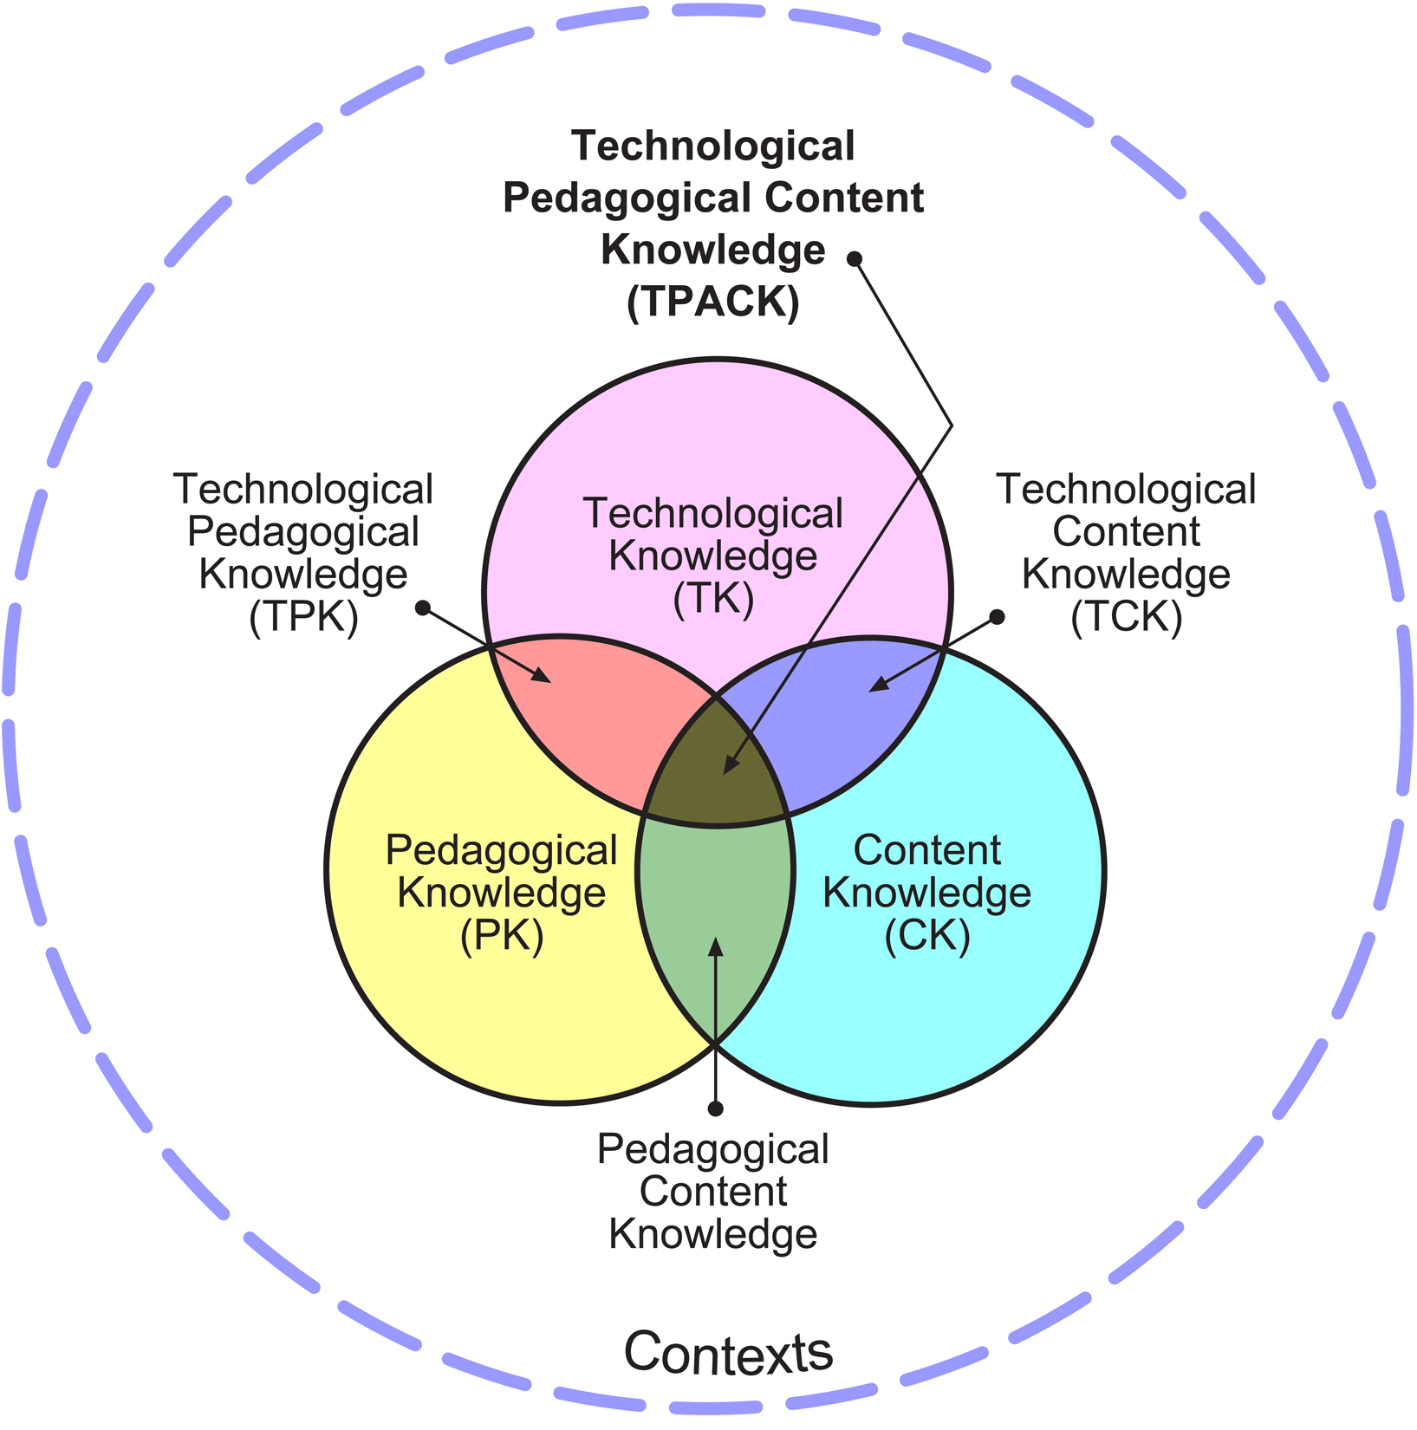
Figure 1. The TPACK framework and its knowledge components (designed by Koehler and Mishra).
METHODOLOGY
This research followed triangulation research method where the researcher used observation and interview research methods. The researcher observed study lessons and interviewed lecturers. These were classroom observations and interviews with the two French lecturer participants. In this process, the researcher coded data for dominant themes that responded to the research questions.
The questions were worded, so the answers were open-ended. Therefore, participants were able to fully express their viewpoints and experiences.
The researcher sampled for two lecturers who teach French full-time and part-time at the university. A further criterion that was important to the researcher was that these lecturers consistently use digital technology devices and platforms such as computers, projectors, and social media in their everyday classroom teaching. Additionally, participants had to have more than at least one year teaching experience of French as a foreign language in the institution.

FINDINGS AND OBSERVATIONS

The findings indicated that the use of technology – enhanced multimedia, helped lecturers meet the goals for effective foreign language instruction in the digital society of graduate work at the Technical University of Kenya.
The frequent use of digital tools available has tremendously changed the student’s attitude towards learning French as foreign language in the institution. In spite of the limited number of digital tools available, it was noted a pattern of positive effects. The study established that technology-supported language learning is at least as effective as human instructors, if not more so. According to Parvin and Salam 2015, most learners find the learning more enjoyable when using ICT.
Technology-based Tools for the Language Classroom used in Technical University of Kenya.
French language instructors at the Technical University have not been left behind the times, they have incorporated the following Technology-based tools in their language classrooms.
- Music and Videos
Out of the 22 classes taught French in Technical University of Kenya at least 15 classes from time to time learn French through music and videos. The instructors do incorporate French music and French videos in their lessons to teach or to test grammar, vocabulary and expressions
Learners can’t sustain their skills on textbook explanations alone — they need the constant reinforcement that authentic sources provide. An important part of the language learning process for our learners will be simply listening to native speakers and picking up new phrases, grammar patterns and more. When they hear their language lessons brought to life, they better understand how to employ their knowledge.
Audio listening exercises can be good for testing what learners can distinguish on their own. That being said, when it comes to music and videos, the video is the pedagogical powerhouse of the two. The combination of pictures, intonations and gestures gives learners context clues that they can’t get from classroom interactions alone.

- Software
The following are some of the software used in the classroom. They have guided practice activities provided by useful software. Here are some of favorites from the (digital) vaults:
- Le Grand Robert & Collins électronique – Version réseau – This is an electronic bilingual dictionary that provides translation from French to English, and from English to French.
- French Vocabulary – « WHO WANTS TO LEARN FRENCH VOCABULARY Version 1.7». This is a Quiz Studio with Beginners’, Intermediate and Advanced levels. It’s a great way for learners’ to master and improve their vocabulary. There is also a « QUIZ STUDIO » where they can creat their own quizzes and challenge their friends.
Out of the 22 classes only 10 classes got an opportunity of using these two softwares listed above.
Challenges of using technologies in teaching
We use it in every facet of our lives these days. But what are the best ways to maximize the effectiveness of technology in the language classroom?
In a classroom setting, technology can help or hinder, focus or distract, depending on its application. There’s a fine line we have to be careful not to cross.
Doing individual exercises on personal devices can isolate learners and rob them of the interactive experience that language learning should be. However, collaborative tools such as Google Docs and blogs can help fuel interaction and keep learners focused on a specific learning goal.

Below are educational websites that the instructors in Technical University are introducing to their learners:
1. Parlons français tv5 monde.com – Students follow along with the online web documents and complete games and workshops regarding the story.
2. Duolingo – Offers free online courses in Spanish, French, Italian, German, Portuguese and English.
3. Memrise – Uses memorization tricks to teach a variety of subjects. There are many classes to choose from, and world language instructors can create their own lessons if they don’t find exactly what they’re looking for.
4. Skype – This is a free live video calling application that can allow learners to interact with native speakers all over the world.
5. FluentU – This is French immersion online. The videos are real authentic videos. It makes it much more interesting. Learning almost becomes an afterthought to the fact that the learners are watching interesting videos.
6. Quizlet – An incredible bank of study aids that have been created by other world language instructors. This resource also allows you to create study and lesson guides and share them as well.
Quizlet is a powerful and flexible online learning platform based on a tried-and-true memorization tool: the flash card. The “sets” of digital cards can be used to drill vocabulary, but also work well for grammar topics like French language gender or verb conjugation. Instructors can create and organize sets of digital cards for their classes and monitor students’ activity and progress on a given set. Learners in turn have access to a huge archive of sets and can easily search for topics of interest. These activities are fun, with plenty of opportunities for working in pairs. All in all, this is a great tool for homework and a classroom activity.
Technical University has a team of Information Technology (IT) professionals to support and manage everything related to technology. The support of the IT specialists allow students to access Wi-Fi within the university therefore they can access internet anywhere, the learners have therefore downloaded francophone videos, music, comics and audio recorder on their devices. The access to technology provided learners the opportunity to do project summative-based tasks such as creating, short plays and short documentary films thereby creating more opportunities for them to develop French language proficiency in a practical, inquiry-based and constructivist manner.

While using Social Media, the participants suggested that learners could read posts, follow francophone celebrities on the media and initiate in classroom discussions about what was trending on social media to create a more authentic learning environment for the learners. This example elucidates one way of integrating technology in the French classroom to connect learners to real-life contexts that are also relevant to their interests. Not only do they watch these celebrities on the screen, but it also gives them an opportunity to go on stage and act their roles
Both participants believed that they effectively used technology into their teaching and pedagogical practice to teach French language, and both were fairly confident in their knowledge of technology and its applications through their own efforts at educating themselves. It was important to each of them that they be progressive and up-to-date with what was new in the realm of technology and education. They also both reported that they enhanced their technological knowledge through collaboration with colleagues and IT specialists. Each participant used different strategies and teaching practices that were reflective and relevant to their learners’ needs, level of proficiency in the French language and their interests. Such examples included featuring current francophone music that reflected the interests of their learners. They also both stressed how important it was that technology equipped them to be responsive to a wider variety of learning styles. In particular, they noted how technology supported multiple learners, especially audio, visual, interpersonal learners.

The participants agreed that printed material is good but it’s more static and the same year-to-year, but with technology we can bring more up-to-date, richer selections of activities for the learners to do. In terms of teaching to different learning styles, it is really important because not everyone is a visual learner, so in addition to the conversation work that they do, they have audio files, songs and films. We witness the emotional learners and the interpersonal strengths and we also notice that when certain activities come out where they are watching a clip and it sparks a discussion and this would not come out the same way if it was from a printed work.

VALUE OF THE STUDY
The arrival of digital technologies in the classroom has revolutionized the teaching of foreign languages and has made learning French possible in Technical University of Kenya.
Technology is very much part of language learning throughout the world at all different levels. We are as likely to find it in the primary sector as much as in adult education.
Another area that technology supports very effectively is project work. Instructors have always tried to encourage learners to learn about things through language. Getting learners to do work about topics that are of interest to them, or topics that are taught in other parts of the curriculum (sometimes called Content and Language Integrated Learning or CLIL) is a great way to improve their skills. Technology makes this possible wherever you are in the world. Instructors and learners can go online to read or listen to material about different areas of interest, and can then write or speak about what they have discovered, telling others in the class or other classes elsewhere in the world.
There are plenty of examples of case studies of instructors doing these kinds of activities, so we can see how technology can be effectively used to support the language development process.

RECOMMENDATIONS

French language Instructors in Technical University need to introduce Internet based reading materials in the French lessons. As the Internet keeps expanding, newsletters, and even journal articles keep listing and pointing out potential Web sites that can be used in language learning. Furthermore, the literature on Web-based instruction reveals numerous personal accounts, informally collected student surveys, or occasionally some pilot studies on students' experiences using Internet-based resources (Brandl, 2002).
A lot still remains to be done by the administration. The lecturers need a lot of support from the administration to develop further the use of digital technology in the French classroom in Technical University of Kenya. In spite of the many benefits of creating an authentic French learning environment with the incorporation of digital technology, the two lecturers also reported that they confronted many challenges integrating technology.
There is also need to create language rooms equipped with computers so that students who do not have laptops can access some of these devices. Wall sockets lack in various classrooms in the university.
Most of the time lecturers are forced to change or improvise their lessons because there is nowhere to plug the machines. Therefore, there is a great need to set aside language rooms.

CONCLUSION
Although elements of the new paradigm for teaching foreign languages are still under development, teaching and learning of French as a foreign language has demonstrated many aspects of the new paradigm to be effective:
1. Achievement of objectives with observable and measurable outcomes and criteria where learners use exploration and available (web) resources to structure their own learning.

2. People learn from real life, games, simulations, television, interactive multimedia and computers. Computers can monitor and guide learners’ performance, administer tests, keep individual student records, and provide statistical data for revision of courseware.

3. The internet has made significant inroads to commerce, healthcare, government, and education. It has revolutionized the way in which information is input, processed, stored, retrieved, and communicated. The ubiquitous computer interface provides instant contact to global resources, with new ways to conduct business and better ways to learn. Hundreds of thousands of schools and universities are supporting their students with Internet resources, and the new learning paradigm is emerging hybrid and stand-alone courses and programs which also applies to foreign language.

REFERENCES
Blackwell, G. (2012, March). Tech class. Professionally speaking, Retrieved from
http://professionallyspeaking.oct.ca/march_2012/features/tech_class.aspx
Brandl K. (2002). Integrating Internet based reading materials into the foreign language curriculum: From teacher to learner centered approach. Language Learning and Technology (LLT Vol6Num3)
Koehler, M. J., & Mishra, P. (2009). What is technological pedagogical content knowledge? Contemporary Issues in Technology and Teacher Education, 9(1). Retrieved from http://www.citejournal.org/vol9/iss1/general/article1.cfm 1st February 2016.

Lawrence, G. (2002). The use of email as a tool to enhance second language education
programs: An example from a core French classroom. Canadian Modern
Language Review, 58, pp. 465-472.

Parvin R.H and Salam S.F. (2015), The Effectiveness of Using Technology in English Language Classroom in Government Primary Schools in Bangladesh; FIRE – Forum for International Research in Education Vol 2, Iss. 1, pp. 47-59
Shulman, L. S. (1986). “Paradigms and research programs in the study of teaching.” In M.C. Wittrock (Ed.), Handbook of research on teaching. New York: MacMillan.
Shulman, L. S. (1986). “Those who understand: Knowledge growth in teaching.” Educational Researcher Feb. 1986: 4-14. (AERA Presidential Address).

