Design and Implementation of Biometric-Based Student Information Retrieval System Using Finger Prints Recognition

*¹OMOROGIUWA, O; ²NWELIH, E; ³AWEH, O

*¹Department of Computer Science & Information Technology, Igbinedion University, Okada, Edo State, Nigeria
²Department of Computer Science, University of Benin, Edo State, Nigeria.
³Department of Mathematical and Physical Sciences, Afe Babalola University Ado-Ekiti, Ekiti State, Nigeria

*Corresponding Author Email: ask4osas@iuokada.edu.ng
Co-Authors Email: emmanuel.nwelih@uniben.edu, opaniaweh@abuad.edu.ng
*ORCID ID: 0000-0003-2105-8220

ABSTRACT: This study designed and implements a biometric-based student information retrieval system using finger print recognition. The findings showed that the existing manual system is prone to lots of errors such difficulties in accessing records, wrong data entry, difficulties in data manipulation, identity management and difficulties in updating students’ records. Structured system analysis and design methodology was adopted for this research. The design and implementation of the developed application software showed that computerized student information retrieval system using biometrics greatly enhanced the documentation, manipulation and retrieval of student information in a more accurate, fast and secured manner.

DOI: https://dx.doi.org/10.4314/jasem.v27i4.25

Open Access Policy: All articles published by JASEM are open access articles under PKP powered by AJOL. The articles are made immediately available worldwide after publication. No special permission is required to reuse all or part of the article published by JASEM, including plates, figures and tables.

Copyright Policy: © 2022 by the Authors. This article is an open access article distributed under the terms and conditions of the Creative Commons Attribution 4.0 International (CC-BY- 4.0) license. Any part of the article may be reused without permission provided that the original article is clearly cited.

Cite this paper as: OMOROGIUWA O; NWELIH, E; AWEH, O. (2023). Design and Implementation of Biometric-Based Student Information Retrieval System using Finger Prints Recognition. J. Appl. Sci. Environ. Manage. 27 (4) 823-827

Dates: Received: 07 February 2023; Revised: 18 March 2023; Accepted: 28 March 2023
Published: 31 March 2023

Keywords: Biometrics systems; Identification system; Information Management; manual processing; computerized processing

Biometric system is an automated recognition of persons based on their biological and behavioral characteristics. Biometrics authentication is used in Computer Science as a form of identification and access control (Jain et al., 2008). Biometric identifiers are the distinctive, measurable characteristics used to label and describe individuals and are categorized as physiological versus behavioral characteristics (Jain et al., 2008). Physiological characteristics are related to the shape of the body. Examples include, but are not limited to fingerprint, palm veins, face recognition, DNA, palm print, hand geometry, iris recognition, retina and odour. Behavioral characteristics are related to the pattern of behavior of a person, including but not limited to typing rhythm, gait, and voice. Some researchers have coined the term behaviometrics to describe the latter class of biometrics (Weaver, 2006). Weaver (2006) study explains two basic modes of a biometric system. Firstly, in verification (or authentication) mode the system performs a one-to-one comparison of a captured biometric with a specific template stored in a biometric database in order to verify the individual is the person they claim to be. Three steps are involved in the verification of a person. In the first step, reference models for all the users are generated and stored in the model database. In the second step, some samples are matched with reference models to generate the genuine and impostor scores and calculate the threshold. Third step is the testing step. This process may use a smart card, username or ID number (e.g. PIN) to indicate which template should be used for comparison. 'Positive recognition' is a common use of the verification mode, “where the aim is to prevent multiple people from using same identity (Jain et al., 2008). Second, in identification mode the system performs a one-to-many comparison against a biometric database in attempt to establish the identity of an unknown individual. The system will succeed in identifying the individual if the comparison of the biometric sample to a template in the database falls within a previously set threshold. Identification mode can be used either for 'positive recognition' (so that the user does not have to provide any information about the template to be used) or for 'negative recognition' of the person “where the system establishes whether the person is who she (implicitly or explicitly) denies to be”. The latter function can only be achieved through biometrics since other methods of personal recognition such as passwords, PINs or keys are ineffective. Most users usually access their information, records or files in the computer system using text based criteria. Some work have been made to develop a computerized information access using human biological or/and behavioral characteristics. (Abioye et al., 2018; Sogbaike and Ahoro 2019) Obviously such an interface would yield greater benefits. Text-based recognition although has its merits, but its weaknesses has necessitated in the use of biometric authentication and verification processes. This study therefore seeks to design and implement a biometric-based student information retrieval system using finger prints recognition in a tertiary institution in Edo State, Nigeria.

MATERIALS AND MEHOD
Structured systems analysis and design methodology was adopted. To vividly understand the operations of an existing manual system, a tertiary institution in Edo State, Nigeria was used as a case study.

Methodology: Observation and interview and studying of relevant materials were used to gather information about the existing system. Furthermore, facts about the existing system were compiled. Structured interview were used.Existing documents reviewed or examined were the department’s input procedure, output procedures, system specifications, file structures and content.

Design of a Biometric System:Figure 1 shows the structure of the proposed system. Initially the student finger prints is scanned, extracted and stored in the database. The captured fingerprint is used to fetch students’ information from the database.

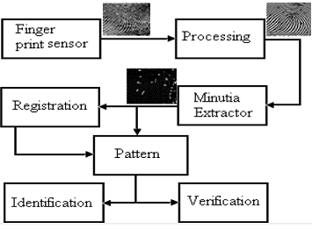
Fig 1: Proposed System Structure

Data Flow Diagram (DFD): The Data flow diagram is shown in Figure 2 and Figure 3 as follows,
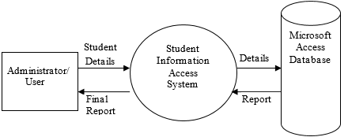
Fig 2: 1 Level 0 DFD
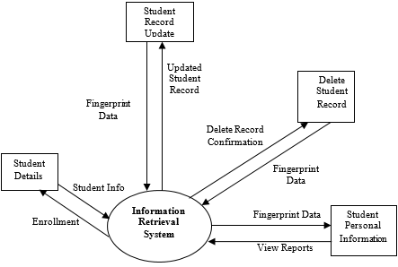
Fig 3: Level 1 DFD

REULTS AND DISCUSSION
The Biometric Based Student Information Retrieval System has one master database file named “DATABASE”. The database file has one table named “STUDENT”. The “STUDENT” table stores information of students in the school such as registration number, surname, first name, middle name, sex, age, class of student. Accessing mode for both files is random. That is recorded in both files and can be read or modified. Also, data validation built into the system enables the discovery of errors in the input data. For instance, if a field is meant for integer and alphabet is mistakenly inputted to the field, the system will prompt the user with the message that there is an error in the input data, and also provide the user the information on how to re-enter the data correctly. Also, the input data to the system are given below in data dictionary. A data dictionary is the description of the structure of the record in each of the file used. The data dictionary for the Student table is shown in Table 1.

Table 1: Data Dictionary for Student Table
S/N | Field Description | Fieldname | Data Type | Field Length
1. | Matriculation Number | Matno | Text | 10
2. | Surname | Surname | Text | 20
3. | First Name | Firstname | Text | 20
4. | Middle Name | Middlename | Text | 20
5. | Sex | Sex | Text | 6
6. | Age | Age | Integer | 2
7. | Level | Level | Integer | 3
8. | Fingerprint | Fingerprint | Ole

Entity Relationship Diagram (ERD):Entity Relationship Diagrams gives a conceptual view of the database. Figure 4 is the entity relations diagram for the biometric based student information retrieval System.

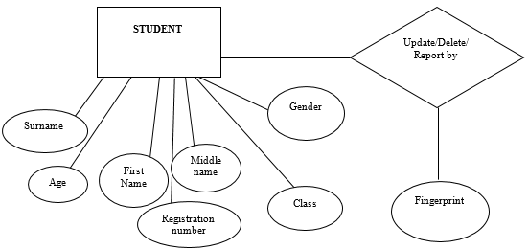
Fig 4: Unified Markup Language (Use Case Diagram and Sequence Diagram)
A breakdown of the Use Case Diagram and Sequence Diagram is shown as in Figures 5 and 6 follows:
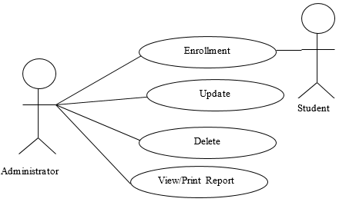
Fig 5: Use Case Diagram for the Biometric Based Information Access System

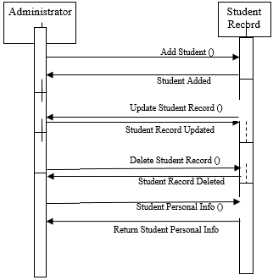
Fig 6: Sequence Diagram for the Biometric Based Information Access System
Programming and Code Testing:After the design, Microsoft Visual Basic was used to develop the software. Normally the program was written as a series of individual modules and this was subjected to separate and detailed test. The separate modules was then brought together and tested as a complete system. The system was tested to ensure that interfaces between modules worked adequately. The system analyzed and compared sample fingerprint data with that of some student whose record is to be referenced to for the purpose of update, deletion or report generation.

System Implementation: This is the stage of software development process where the system is fully implemented by the user. For the system to be implemented, the prototype system first needs to be accepted by the user. Once the system is fully accepted by the user, the system is test run with real life data and any other relevant data where appropriate and applicable. The system designed and developed is a biometrics-based student information retrieval system and as such, for the system to be implemented, the following will require users’ training requirements, system testing, system review and maintenance. The functionality of the system is shown in the output screenshots of the application. Thus, screenshot 1 depicts the home screen consisting of the main menu and other relevant information about the developed application. Screenshot 2 depicts the student record entry module showing basic input of student information including the fingerprint data. Screenshot 3 shows a sample student record update requiring fingerprint data as a necessary requirement to determine access to the update role in the database.

Sample Output Screenshots: An output screen is a device used to display output. An output screen could be a separate monitor or another display device used only to display the output being received from the computer or other devices. Output, Video terms. Three sample output shots were made from this work and are presented as Screenshot 1, screenshot 2 and screenshot 3.

The Screenshot 1 is the MAIN MENU

The Screenshot 2 is the SAMPLE INPUT DATA

While the Screenshot 3 is SAMPLE INPUT DATA FOR UPDATE
Screenshot1: MAIN MENU

Screenshot 2: SAMPLE INPUT DATA

Screenshot 3: SAMPLE INPUT DATA FOR UPDATE

Conclusion: Biometric based student information retrieval system has been shown to be highly effective in enhancing systems and files security. The research work has presented a platform for the practical development and design of a biometric based student information retrieval system. The system was designed using the Visual BASIC programming language. The system was analyzed and compared sample fingerprint data with that of a student whose record is to be referenced to for the purpose of update, deletion or report generation. This was done to validate the functionality of the developed biometric application. The system when fully implemented will ensure that students’ records are access and retrieved with ease in a secured manner.

REFERENCES
Abioye, M; Abioye, AE; Omotehinwa, OT; Egonwa, BO; Oluwe, MO (2018). Design and Implementation of a Fingerprint Based Identitiy Management System.Inter. J. Latest Technol. Engineer. Manage. Appl. Sci. 7 (8):1-7

Jain, K.; Barber, C; Noyes, J (2008). Biometric Fingerprint Recognition. Human Factors. 38(1). 142-156.

Sogbaike, CO; Ahoro, VO (2019). Design and Implementation of Class Attendance Management System Using Fingerprint Recognition. Inter. J. Sci. Res. Pub. 9(5): 882 – 897.

Weaver, H (2006). “How Finger Print Recognition Works”. Available online at: http://electronics.howstuffworks.com/speech-recognition.htm.

