ESARBICA JOURNAL

JOURNAL OF THE EASTERN

AND SOUTHERN AFRICA

REGIONAL BRANCH OF THE

INTERNATIONAL COUNCIL ON

ARCHIVES

Volume 31

2012

ISSN 2220-6442 (Print), ISSN 2220-6450 (Online)

HOW DOES LIBRARY AND INFORMATION SCIENCE PERCEIVE RECORDS MANAGEMENT? A TREND AND CORE/PERIPHERY MODEL ANALYSIS

Omwoyo Bosire Onyancha¹ and Koketso Mokwatlo²
University of South Africa, Department of Information Science
¹onyanob@unisa.ac.za and ²mokwaki@unisa.ac.za

Received: 2 March 2011
Revised: 25 June 2011
Accepted: 1 August 2011

Abstract

It has been observed that the scope of records management (RM) and the concept’s definition is still unclear. The problem is compounded by the emergence of new formats of “records” – a situation that calls for a re-examination of the definition of RM. This article offers an informetric perspective of understanding the concept through an analysis of the subject headings which are used to describe RM in the published literature that represent RM research. By using various analytical technologies to analyse the data extracted from the Library, Information Science and Technology Abstracts (LISTA) database, the study found that RM is increasingly becoming synonymous with information resources management (IRM), which features prominently in the RM literature as a subject heading. The core subject terms that are commonly used to describe RM include “management”, “records”, “information”, “resources”, “electronic”, “systems”, “archives”, “documents”, “services” and “computer”. Based on the findings of this study, we conclude that RM is related to IRM and is practiced in places such as archives, libraries and business enterprises by librarians, archivists, information professionals and records managers who use different enablers – such as computer software and systems to manage (e.g. process, plan, control and/or coordinate) various types of information resources (e.g. electronic documents, records, manuscripts, etc.). Further areas of research are recommended.

Keywords
Records management, informetrics, content analysis, information resources management

Introduction

In his article on the future of records management (RM), Pemberton (1991) raises pertinent questions about RM. He asks: “Is records management a business function? Is it an information function or both a business and information function? What is in the actual domain of records management; what falls outside it?” The author further asks: “Are graphics, mail service and telecommunications really part of the domain of records management? Is it time now, looking to the future, for a name change that is more than simply cosmetic? Is RM ‘information management’ or ‘information resources management’?” As if to underscore the enormous task of defining the concept of RM, Ryan (2006) reports that during a seminar conference with the theme “Exploring the essence of records management: engaging experts” that was held in Newcastle upon Tyre (UK) in 2006, there was an “extremely, quite profound, quite intense one-and-half-day period” debate on what RM is about. Some of the interesting questions that were posed at the conference, which perhaps indicate the different meanings attached to RM, include: Is records management the management of risk? Who are the records managers? Is RM a discipline or field of study, or both? Is it just a subject of study within a discipline such as library and information science and/or business management?

The term “records management” was coined in 1949 at the U.S. National Archives. Originally, RM was offered in the curricula for Business Administration or Business Education. The concept has evolved over time and has been included in the curricula of other subjects such as Library and Information Science and Computer Science. Despite the fact that the importance of RM is increasing both in the private sector and in the public sector, there are still ambiguities and misunderstandings around the concept itself (De Boisdeffre 2006:77). The difficulties experienced in conceptualising RM emanates from the vocabularies associated with the concept, such as “archive”, “records” and “management”. These vocabularies differ in their usage, depending not only on the language of a particular region but also on a country’s laws. For instance, De Boisdeffre (2006:77) observes:
In French law, an archive is any document received or produced by an individual or organisation in the context of their professional responsibilities, from its point of creation onwards. The word “record” for its part is very difficult to translate into French. It cannot be assumed to be the same as “document” but it implies the idea of selection, that is those documents produced or received by an individual or organisation in the context of their professional responsibilities and whose capture and preservation, in the context of its creation, are necessary for the smooth running of business activities and for knowledge and monitoring them.

Loadman (2001) also acknowledges that there is a variety of definitions of records management. She, however, notes that the thrust of most definitions is that RM “manages records from creation to disposition irrespective of what media in which they are created or stored” (Loadman 2001:46). The author hopes that the records management profession can agree on standard definitions. Just as there is a variety of definitions of records management, so is the case with the definitions of a record.

Even the practice of RM in organisations that fall under the same sector manifests differences. For instance, King, Hare and McLeod (1996:6) note in their study of continuing professional development for the information discipline of records management that there is a “lack of consistency of records management practice among organizations in the same sector”. The search for a universally agreed upon definition or description of RM is ongoing but proves difficult, especially with the emergence of ICT (information and communication technology)-generated “records”, which also present new challenges in the management of records (Mnjama & Wamukoya 2007). In addition, RM is increasingly becoming multi-disciplinary in nature. RM is also practised in a variety of sectors, such as the medical, financial, legal, media and engineering professions (King, Hare & McLeod 1996). In the midst of all these developments, which include the use of ICTs in the handling of records, we believe that RM has widened to include other aspects that were hitherto not covered in its scope. As a result, it is clear that there is a need for concerted efforts towards providing alternative approaches to gaining a better understanding of the concept of RM as it evolves.

This study is an endeavour to provide a synopsis of what constitutes RM as perceived by the Library and Information Science (LIS) researchers. The main purpose of the study is to examine the subject terms that are commonly used to index RM research with a view of discovering the concepts that are related to RM. We assume, in this study, that the most frequently used subject terms in the RM literature will have a bearing on how authors view the main concept (in this case, RM) and what terms the authors perceive to describe the concept under investigation in their research. In view of this purpose, the study sought to fulfil the following objectives:

- To find out the publications patterns of RM literature
- To examine the shift in subject headings in RM literature with a view to determining the emerging topics of RM research
- To determine the core subject headings that are used to describe the scope and definition of RM
- To measure the strengths of association among RM core subject terms
Methods and materials

This article employed informetrics techniques, more specifically subject content analysis, to examine the growth of the concept “records management” over time and the core compound subject terms that described the concept between 1971 and 2009 as well as to discuss the LIS scholars’ perceptions of RM. At this stage, the findings are reported in this paper based on the published RM research as indexed in the Library, Information Science and Technology Abstracts (LISTA) database. LISTA is a subject-specific database that is delivered via the EBSCOhost platform and indexes more than 560 core journals, nearly 50 priority journals and 125 selective journals as well as books, research reports and proceedings. It is one of the most comprehensive information science-specific databases and covers topics such as librarianship, classification, cataloguing, bibliometrics, online information retrieval and information management, among others. Its subject coverage extends as far back as the 1960s – a situation that makes it perhaps the oldest database in Information Science.

Relevant data was extracted from the database by using the search query ‘SU’ “Records – Management” upon browsing the EBSCOHost thesaurus for the appropriate subject term under which records management records are indexed in LISTA. The searchable tag ‘SU’ performs a keyword search of subject headings, companies, people and author-supplied keywords for terms that describe a document's contents. For the purposes of conducting this study, only subject headings were considered for analysis. The use of the subject term “records – management” as a search term was meant to yield only the documents that are specific to RM. The search was therefore limited to the subject field of the records. The time period was limited to 1971 to 2009, given that the earliest published RM document as indexed in LISTA was published in 1971. The relevant data was then saved as text (.txt) files in order to comply with the computer software that was used for analysis. Data was cleaned using the Notepad by removing irrelevant data, such as the name of the database and copyright ownership which were automatically downloaded when extracting the data. The author-supplied keywords, geographic regions and people’s names were also removed in order to remain with only subject headings.

The data was analysed by using various computer-assisted software, namely UCINET for Windows, BIBEXCEL, TI and TextSTAT. Whereas the UCINET for Windows software was used to generate a core/periphery model, Pajek was used to visualise the relationship between words and to produce the social network illustrated in figure 2. TextSTAT is the software that counts the frequencies of word occurrences in a given text and it was used to identify the most commonly used single words within the subject terms. The generated list of the most common single subject terms was then subjected to analysis by using the TI software in order to produce a co-occurrence matrix, which was in turn subjected to the core/periphery analysis and social network analysis as illustrated in Figures 1 and 2.

By using the principle of the most productive units of analysis (i.e. authors, journals, texts, countries, institutions, etc.) which contribute the most number of articles or words, this study adopted the bibliometric laws’ approaches as a partial indicator of the core and peripheral subject headings that can be used to describe RM. The most common subject headings were considered core subjects that can assist in describing or defining the scope of, and therefore reflect, the perceptions of LIS scholars about RM. In this respect, we considered the 20 most common subjects as the main descriptors of the scope of RM in each year of the four 10-year periods. In addition to this approach, a core/periphery model analysis was conducted to identify the subject terms that comprise the core of RM and those that fall under the peripheral cluster of subject terms. Basically, the analysis fits a core/periphery model to the data network, and identifies which actors belong in the core and which belong in the periphery (Borgatti & Everett 1999). This technique has been used by Ocholla, Onyancha and Britz (2010) and Onyancha and Ocholla (2009a) in order to, respectively, find out the core topics or subjects that can be used to describe information ethics and knowledge management. The terms ”records” and ”management” were excluded from the analysis of the core/periphery model as well as from the social network analysis since they could have created a convergence of words around them – a situation that could have exaggerated the links among the terms and could therefore have influenced the clusters.

Findings and discussion

The findings of this study are presented and discussed under the following headings:
- RM publications output
- Most common subject terms in RM literature
- Core/periphery model of RM literature
- Social network of RM subject terms

RM publications output

The yearly distribution of RM publications in the past four decades is depicted in figure 1. From just 21 records from 1971 to 1980, RM publications grew exponentially to 2216 publications from 2001 to 2009. There were 132 (5%) publications from 1981 to 1990 and 335 (12%) from 1991 to 2000. A similar trend was observed with regard to the number of subject headings that were used to index the publications. There was, however, a mixed pattern of growth in the average number of subject headings per publication. The largest number of average subject headings per publication (i.e. 2.5) was recorded for the 1971 to 1980 year period, followed by the periods 2001 to 2009 (1.0), 1991 to 2000 (0.9) and 1991 to 2000 (0.8).

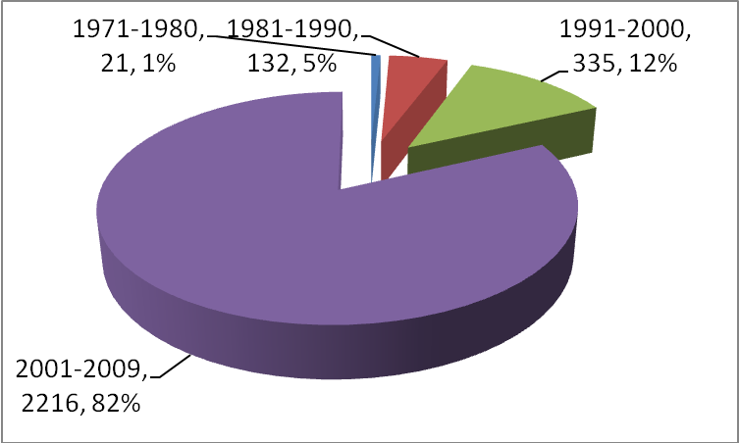
Figure 1: Number of RM publications, 1971–2009

Most common compound subject terms in RM literature

Period 1971–1980

This period yielded low frequencies of occurrence with a total of 52 subject headings, including “Records Management”. The most common subject term was “archives”, which yielded a total of seven articles out of the total 21 articles that were published between 1971 and 1980. In the second position, with three records each, were “information resources management” and “automation”. 11 out of the total 53 (a percentage representation of 21.2%) subject terms appeared 29 times, thereby accounting for 41.4% of the total 70 occurrences of all the subject terms. The 11 terms included “computers”, “information science”, “information storage and retrieval systems”, “information services”, “information retrieval”, “information resources”, “algorithms” and “public records”. The remaining subject terms, which numbered 40, appeared in one record each.

Period 1981–1990

The subject headings increased from 52 in the 1971 to 1980 year period to 116 in the 1981 to 1990 year period, thereby recording a percentage growth of 123%. As was the case from 1971 to 1980, the subject heading “Archives” was the most frequent, with appearances in 61 (46.2%) out of the total 132 documents that were published between 1981 and 1990 on RM. Other subject headings that were commonly used to describe RM literature include “History” (7, 5.3%), “Manuscripts” (7, 5.3%) and “Databases” (6, 4.5%). It was noted that terms such as “databases”, “libraries”, “automation”, “microfilms” and “information storage and retrieval systems” were also encountered in the 1971 to 1980 period, which implies the use of technology in RM.
Table 1: Distribution of RM publications, 1981–1990 (N=132)
No. | Subject headings | Records | Percentage
1 | Records – Management | 132 | 100.0
2 | Archives | 61 | 46.2
3 | History | 7 | 5.3
4 | Manuscripts | 7 | 5.3
5 | Databases | 6 | 4.5
6 | Education | 5 | 3.8
7 | Collection Management (Libraries) | 5 | 3.8
8 | Political Science | 5 | 3.8
9 | Information Services | 4 | 3.0
10 | Libraries | 4 | 3.0
11 | Libraries – Automation | 4 | 3.0
12 | Associations, Institutions, etc. | 4 | 3.0
13 | Microfilms | 4 | 3.0
14 | Library Science | 3 | 2.3
15 | Business | 3 | 2.3
16 | Information Storage and Retrieval Systems | 3 | 2.3
17 | Documentation | 3 | 2.3
18 | Information Retrieval | 3 | 2.3
19 | Database Management | 3 | 2.3
20 | Design | 2 | 1.5

Period 1991–2000

Table 2 shows the top 20 subject headings that were used to index RM publications between 1991 and 2000. Topping the list of subject headings was “Records – Management”, which was used to describe the contents of 335 (100%) publications. In the second position was “Archives”, with 54 (16.1%) appearances, followed by “Information Services” (31, 9.3%), “Document Delivery” (22, 6.6%), and “Information Storage and Retrieval Systems” (16, 4.8%). This period, just like its predecessor, witnessed a strong presence of electronic or technology-related terms such as “information storage and retrieval systems”, “computer software”, “electronic documents”, “information networks”, “information retrieval”, “information technology”, “libraries – automation”, “online databases, “Web sites” and “electronic information resource searching”. It was also observed that 11 out of the 20 subject headings listed in table 2 emerged as the most common subject headings from 1991 to 2000. Besides some of the aforementioned subject headings relating to technology, other subject headings that emerged among the top 20 from 1991 to 2000 were “Information Resources Management” and “Management”. A comparison between table 1 and table 2 also revealed that several subject headings that featured prominently in table 1 had disappeared, so to speak, in the 1991 to 2000 period. These included “History”, “Manuscripts”, “Education”, “Collection Management (Libraries)”, “Political Science”, “Libraries”, “Microfilms”, “Library Science”, “Database Management”, and “Design”.
Table 2: Distribution of RM publications, 1991–2000 (N=335)
No. | Subject headings | Records | Percentage
1 | Records – Management | 335 | 100.0
2 | Archives | 54 | 16.1
3 | Information Services | 31 | 9.3
4 | Document Delivery | 22 | 6.6
5 | Information Storage and Retrieval Systems | 16 | 4.8
6 | Associations, Institutions, etc. | 15 | 4.5
7 | Computer Software | 14 | 4.2
8 | Electronic Documents | 13 | 3.9
9 | Information Networks | 13 | 3.9
10 | Business | 12 | 3.6
11 | Information Retrieval | 11 | 3.3
12 | Information Resources Management | 10 | 3.0
13 | Information Technology | 10 | 3.0
14 | Libraries – Automation | 10 | 3.0
15 | Management | 10 | 3.0
16 | Online Databases | 9 | 2.7
17 | Databases | 8 | 2.4
18 | Web Sites | 8 | 2.4
19 | Documentation | 7 | 2.1
20 | Electronic Information Resource Searching | 7 | 2.1

Period 2001–2009

This period witnessed the biggest leap not only in terms of the number of publications, but also in terms of the number of subject headings used to describe RM literature. From the previous period’s 273 subject headings, the number increased eight-fold to 2135 from 2001 to 2009. Explaining this type of increment of subject headings in their article on HIV/AIDS research, Bierbaum and Brooks (1995:533) opine that variances in indexing intensity may have been due to “changes in literature (such as greater complexity of individual articles) or to a greater depth and thoroughness”. The same pattern was observed in Onyancha and Ocholla’s (2009b) study of the subject content of HIV/AIDS research in eastern and southern Africa between 1980 and 2005. Whether the patterns of growth that were witnessed in this study in terms of the growth in the number of subject headings used to index RM literature can be attributed to any of aforementioned factors is hard to say. One can however argue that RM literature is not complex enough to warrant an application of many subject headings to describe it nor does it require in-depth indexing as the topics of research are rather straightforward. However, with the emergence of new formats of records, one would expect an increase in the number of subject headings used to describe the content of RM.

Table 3 shows that among the most frequent subject headings from 2001 to 2009 – besides “Records – Management” – were “Information Resources Management”, which posted a total of 931 publications that accounted for 42.0% of the total 2216 publications. Other subject headings that featured prominently in this period included “Electronic Documents” (511, 23.1%), “Information Services” (319, 14.4%), “Archives” (293, 13.2%), “Information Science” (243, 11.0%), “Information Technology” (193, 8.7%), “Documentation” (184, 8.3%), “Web Sites” (147, 6.6%) and “Electronic Information Resources” (128, 5.8%) – just to name the top 20. It is worth noting that major shifts occurred with regard to the ranking of some of the subject headings. Whereas such subject headings as “Information Resources Management”, “Electronic Documents”, “Information Technology”, “Documentation”, “Web Sites” and “Management” improved their positions, “Information Services”, “Archives”, “Information Retrieval”, “Computer Software”, “Information Storage and Retrieval Systems” and “Associations, Institutions, etc.” dropped in their rankings. A total of six subject headings were new or re-emerged during this period. These were: “Information Science”, “Electronic Information Resources”, “Libraries”, “Library Science”, “Business Enterprise” and “Electronic Records”.
Table 3: Distribution of RM publications, 2001–2009 (N=2216)
No. | Subject headings | Records | Percentage
1 | Records – Management | 2216 | 100.0
2 | Information Resources Management | 931 | 42.0
3 | Electronic Documents | 511 | 23.1
4 | Information Services | 319 | 14.4
5 | Archives | 293 | 13.2
6 | Information Science | 243 | 11.0
7 | Information Technology | 193 | 8.7
8 | Documentation | 184 | 8.3
9 | Web Sites | 147 | 6.6
10 | Electronic Information Resources | 128 | 5.8
11 | Management | 123 | 5.6
12 | Information Retrieval | 120 | 5.4
13 | Computer Software | 118 | 5.3
14 | Information Storage and Retrieval Systems | 118 | 5.3
15 | Information Resources | 107 | 4.8
16 | Associations, Institutions, etc. | 106 | 4.8
17 | Libraries | 101 | 4.6
18 | Library Science | 101 | 4.6
19 | Business Enterprises | 98 | 4.4
20 | Electronic Records | 97 | 4.4

Single terms in the subject headings

An analysis of the single subject terms was meant to reflect the number of hits each term appeared in the subject headings with a view to finding the most common single subject terms in the RM literature. It was observed that the term “management” registered the highest number of hits (i.e. 4350), followed by “record/s” (3181), “information” (2388), “resources” (1320), “electronic” (1142), “systems” (693), “archives” (570), “documents” (542), “services” (533) and “computer” (530) – to name those terms that recorded 500 or more hits. It was noted that the pattern reported in table 4 is similar to the pattern reflected among the top 10 compound subject headings, with one difference being that the subject heading “Web Sites” has been substituted by “Systems”, which was an aspect of number 14 in the latter table. This implies that overall the top 10 (or so) subject headings may be taken to constitute the core terms with which RM can be described or be associated.
Table 4: Single subject terms in RM, 1971–2009
No. | Single subject term | Hits | No | Single subject term | Hits
1 | Management | 4350 | 1 | Archival | 163
2 | Records | 3181 | 2 | Institutions | 149
3 | Information | 2388 | 3 | Internet | 143
4 | Resources | 1320 | 4 | Materials | 143
5 | Electronic | 1142 | 5 | Industrial | 135
6 | Systems | 693 | 6 | Associations | 133
7 | Archives | 570 | 7 | Government | 130
8 | Documents | 542 | 8 | Filing | 118
9 | Services | 533 | 9 | Law | 116
10 | Computer | 530 | 10 | Enterprises | 113
11 | Science | 473 | 11 | Digital | 108
12 | Libraries | 392 | 12 | Education | 105
13 | Business | 334 | 13 | Mail | 102
14 | Library | 318 | 14 | Access | 98
15 | Web | 316 | 15 | Congresses | 98
16 | Retrieval | 314 | 16 | United | 98
17 | Software | 285 | 17 | Knowledge | 97
18 | Technology | 271 | 18 | Networks | 97
19 | Data | 256 | 19 | States | 97
20 | Documentation | 206 | 20 | Organisation | 96
21 | Processing | 188 | 21 | Planning | 89
22 | Public | 187 | 22 | Research | 88
23 | Storage | 177 | 23 | Development | 86
24 | Sites | 174 | 24 | Industry | 85
25 | Document | 172 | 25 | Office | 84

Co-occurrence of single subject terms

Table 5 contains the frequencies of co-occurrence of a pair of single subject terms in the subject headings used to index RM. This analysis was meant to identify other two-word phrases that could be used to describe RM as a concept as well as describe RM literature. For instance, the name “information resources management” can be broken down into several permutations of two words each, among which are: “information and resources”, “information and management” and ‘resources and management”. These three variations can still be used to describe RM. Table 5 reveals that the pair of terms that had the highest co-occurrence was way ahead of the others. These terms were “information” and “resources”, which recorded a frequency count of 2657 co-occurrences in the compound subject headings of RM literature that was published between 1971 and 2009.

It can be noted from Table 5 that whereas “Information Resources Management” (as a compound subject heading) was used to index a total of 945 RM publications, a combination of “Information” and “Resources” recorded a much higher frequency count of co-occurrence (i.e. 2657). The next three high co-occurring pairs of single subject terms in descending order of frequency were “Information” and “Electronic” (1516), “Information” and “Systems” (1198), and “Information” and “Archives” (440). “Information” and “Science” co-appeared 904 times, while “Electronic” and “Resources” appeared together in 868 subject headings and “Information” and “Retrieval” co-occurred 770 times. Other frequencies of co-occurrence between a pair of terms were lower than 600. Any combination of two words in table 5 will therefore partly be representative of the terms that can be used to describe RM’s scope in terms of activities, processes, services, resources, institutions and functions.

Table 5: Co-occurrence of single subject terms in RM literature, 1971–2009

No. | Subject term | 1 | 2 | 3 | 4 | 5 | 6 | 7 | 8 | 9 | 10 | 11 | 12 | 13 | 14 | 15 | 16 | 17 | 18 | 19 | 20
1 | Information |  | 2657 | 1516 | 1198 | 440 | 791 | 1104 | 598 | 904 | 402 | 405 | 330 | 278 | 770 | 324 | 558 | 338 | 302 | 221 | 202
2 | Resources | 2657 |  | 868 | 490 | 250 | 390 | 328 | 348 | 308 | 158 | 212 | 128 | 184 | 217 | 176 | 179 | 141 | 120 | 90 | 81
3 | Electronic | 1516 | 868 |  | 561 | 182 | 748 | 232 | 327 | 191 | 138 | 144 | 76 | 219 | 142 | 165 | 128 | 207 | 57 | 185 | 84
4 | Systems | 1198 | 490 | 561 |  | 63 | 320 | 135 | 305 | 126 | 61 | 106 | 40 | 54 | 272 | 131 | 108 | 167 | 48 | 93 | 24
5 | Archives | 440 | 250 | 182 | 63 |  | 88 | 95 | 48 | 85 | 71 | 18 | 55 | 52 | 39 | 19 | 17 | 13 | 76 | 17 | 68
6 | Documents | 791 | 390 | 748 | 320 | 88 |  | 172 | 213 | 101 | 69 | 75 | 57 | 144 | 71 | 110 | 88 | 77 | 27 | 75 | 36
7 | Services | 1104 | 328 | 232 | 135 | 95 | 172 |  | 94 | 134 | 170 | 76 | 92 | 94 | 75 | 68 | 67 | 42 | 60 | 31 | 52
8 | Computer | 598 | 348 | 327 | 305 | 48 | 213 | 94 |  | 162 | 43 | 70 | 27 | 128 | 65 | 306 | 77 | 145 | 22 | 110 | 17
9 | Science | 904 | 308 | 191 | 126 | 85 | 101 | 134 | 162 |  | 120 | 30 | 222 | 45 | 79 | 51 | 61 | 78 | 90 | 74 | 27
10 | Libraries | 402 | 158 | 138 | 61 | 71 | 69 | 170 | 43 | 120 |  | 6 | 207 | 59 | 40 | 22 | 25 | 22 | 36 | 12 | 61
11 | Business | 405 | 212 | 144 | 106 | 18 | 75 | 76 | 70 | 30 | 6 |  | 10 | 14 | 35 | 56 | 51 | 43 | 9 | 30 | 6
12 | Library | 330 | 128 | 76 | 40 | 55 | 57 | 92 | 27 | 222 | 207 | 10 |  | 52 | 32 | 14 | 18 | 18 | 49 | 19 | 31
13 | Web | 278 | 184 | 219 | 54 | 52 | 144 | 94 | 128 | 45 | 59 | 14 | 52 |  | 31 | 54 | 15 | 20 | 9 | 20 | 17
14 | Retrieval | 770 | 217 | 142 | 272 | 39 | 71 | 75 | 65 | 79 | 40 | 35 | 32 | 31 |  | 23 | 34 | 48 | 36 | 32 | 6
15 | Software | 324 | 176 | 165 | 131 | 19 | 110 | 68 | 306 | 51 | 22 | 56 | 14 | 54 | 23 |  | 37 | 41 | 17 | 36 | 5
16 | Technology | 558 | 179 | 128 | 108 | 17 | 88 | 67 | 77 | 61 | 25 | 51 | 18 | 15 | 34 | 37 |  | 32 | 15 | 21 | 15
17 | Data | 338 | 141 | 207 | 167 | 13 | 77 | 42 | 145 | 78 | 22 | 43 | 18 | 20 | 48 | 41 | 32 |  | 19 | 175 | 7
18 | Documentation | 302 | 120 | 57 | 48 | 76 | 27 | 60 | 22 | 90 | 36 | 9 | 49 | 9 | 36 | 17 | 15 | 19 |  | 19 | 16
19 | Processing | 221 | 90 | 185 | 93 | 17 | 75 | 31 | 110 | 74 | 12 | 30 | 19 | 20 | 32 | 36 | 21 | 175 | 19 |  | 6
20 | Public | 202 | 81 | 84 | 24 | 68 | 36 | 52 | 17 | 27 | 61 | 6 | 31 | 17 | 6 | 5 | 15 | 7 | 16 | 6

Core/periphery model of RM literature

A total of 100 single subject terms that occurred 40 or more times in the compound subject headings were subjected to analysis by using the core/periphery model as explained in the methodology. Two classes of cluster memberships were obtained as reflected in Figure 2. Cluster 1 consisted of 27 terms, accounting for 27% of 100 terms while cluster 2 comprised 71 (71%) terms. The core terms that can be used to describe the scope of RM belonged to cluster one and include “information”, “resources”, “electronic”, “systems”, “archives”, “documents”, “services”, “computer”, “science” and “libraries”. Others are “business”, “library”, “Web”, “retrieval”, “software”, “technology”, “data”, “documentation”, “processing”, “storage”, “sites”, “Internet”, “materials”, “digital”, “networks”, “development” and “world”.

The core/periphery model reveals that there is a strong association of terms between “Web” and “sites” which generated a strength of association value of 0.851, followed by “information” and “resources” (0.773), “storage” and “retrieval” (0.716), “documents” and “electronic” (0.629), “data” and “processing” (0.607), “Web” and “world” (0.553), and “information” and “services” (0.500). Most of the terms which reflect a strong association seem to imply that they are technologically/electronically oriented/based. Such a pattern may in turn suggest that RM is increasingly being perceived as focusing on electronic-based records – a trend that has widely been published in the RM literature (e.g. Walters, 1995; Yusof & Chell 1998; Yusof & Chell 2002). Although the core/periphery model does not reflect when certain subject terms (especially those rooted in the use of technology) became dominant, we argue that the exponential growth thereof thrived as from the 1990s (as reflected in Tables 2 and 3 respectively). In the second cluster of class memberships are terms that can be considered to belong to the periphery.

Social network of RM literature

As a way of triangulation, the co-occurrence matrix that was used to generate Figure 2 was subjected to network analysis in order to visualise the relationships between the top 100 single subject terms. The nodes in figure 2 represent the most common terms in subject headings, while the links that join two or more terms represent the co-occurrence of the terms. It can be noted that, unlike in the analysis of the core/periphery model where the emphasis was on the co-occurrence of two terms, the social network in figure 3 provides relationships among two or more terms. Figure 3 shows that there are single subject terms that have high links to both the core and periphery terms. These terms are reflected within the radius of the circle at the centre of the illustration, although not all of them are immediately visible. Among these single subject terms are “collection”, “national”, “administration”, “management”, software” and “archival” – to name a few. The strength of their networks is portrayed by overwhelmingly criss-crossing links, resulting in them being indistinguishable at the nucleus of the network. These and many more terms constitute the core terms around which RM’s scope and definition can be built in the current information age. The terms that are located outside the circle constitute what can be called the peripheral single subject terms.

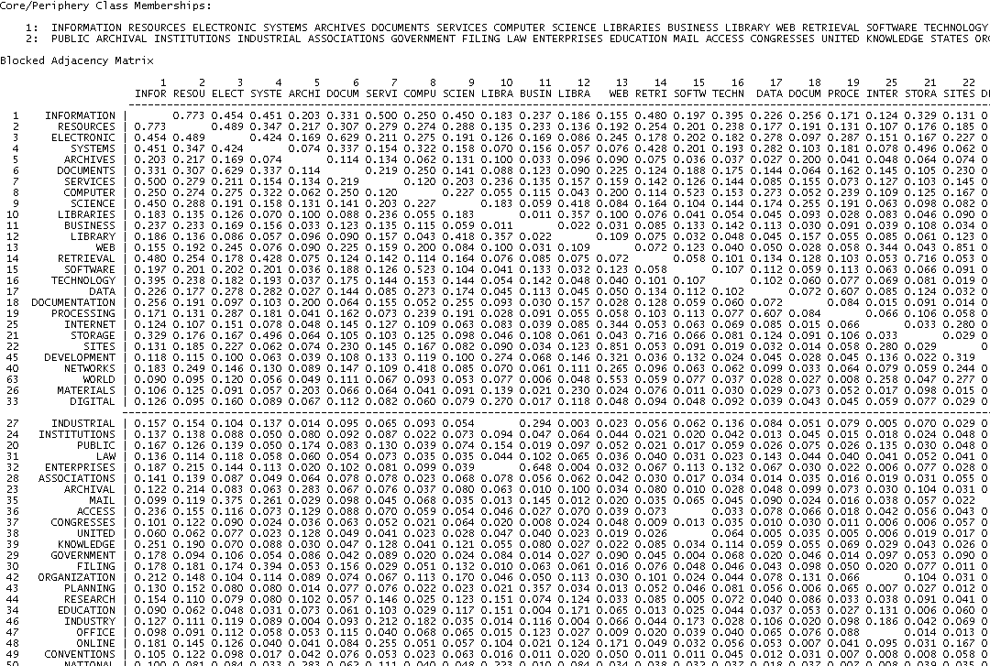
Figure 2: Core/periphery model of RM, 1971–2009

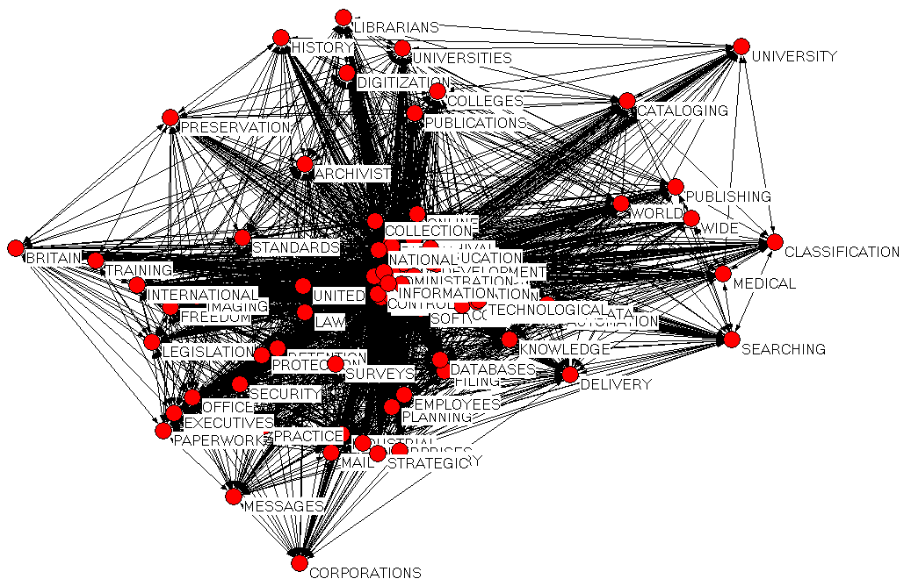
Figure 3: Social networks of most common single subject terms, 1971–2009
Conclusions and recommendations

In this article perceptions of LIS scholars about RM were examined by means of the subject headings that were most associated with RM in each of the four 10-year periods as well as by means of the core/periphery model and network analysis. Each period revealed the subject headings that were most commonly used to describe RM literature, thereby implying close associatedness of the subject headings to RM and in turn the LIS scholars’ perception of the concept. In the 1971 to 1980 period, LIS scholars largely associated RM with “Archives”, “Information Resources Management”, “Automation” and “Computers”, while in the next period (i.e. 1981–1990) “Archives”, “History”, “Manuscripts” and “Databases” were the most common subject headings that were used to describe RM. Between 1991 and 2000, the main focus of LIS scholars was on “Archives”, “Information Services”, “Document Delivery”, “Information Storage and Retrieval Systems”, “Computer Software”, “Electronic documents”, “Information Networks”, “Business” and “Information Retrieval”. The pattern remained almost similar in from 2001 to 2009 when LIS scholars associated RM mainly with the following subject headings: “Information Resources Management”, “Electronic Documents”, “Information Services”, “Archives”, “Information Science”, “Information Technology”, “Documentation”, “Web Sites”, “Electronic Information Resources” and “Management”. From the foregoing presentation, it was observed that the subject heading “Archives” featured consistently among the top most common subject headings. The term was also the most prevalent in the 1971 to 1980 period. This pattern is in tandem with the practice of RM whereby RM was purely conducted within national archives or constituted the management of archives and manuscripts. Of late, other records or resources that have to be managed under RM have proliferated to include other formats. It was not surprising, therefore, to see the subject heading ”Information Resources Management” emerges as the topmost among the subject headings that describe RM as a concept on the one hand and its literature or research on the other hand. The trend seems to suggest that information resources management (IRM) is increasingly becoming strongly associated with RM. This study concurs with Walters (1995:141) when he argues that “with the advent of computer-generated information, the name “records management” has essentially evolved into “information resource management”. Walters seems to suggest that RM may fall away and be replaced with IRM. Whether or not this is true is a matter of debate. We, however, conclude – unlike Walters asserts – that IRM can be treated as a related term of RM. The subject heading appeared 945 times, accounting for 34.95% of the total number of RM publications that were analysed in this study. Other subject headings that frequently appeared in RM in descending order of frequency include: “Electronic Documents” (525, 19.42%) and “Archives” (415, 15.35%).

In conclusion, we argue that LIS scholars view RM as being part of or synonymous with IRM. According to the findings presented in section 3 above, LIS scholars’ perception of RM’s scope can be summarised as comprising the following:

- Functions/activities (e.g. information resources management, management, knowledge management, industrial management, data protection, collection management, strategic planning, automation, Web site development, business planning, database management, paperwork [office practice], etc.).
- Tools or enablers (e.g. Web sites, computer software, technology, information storage and retrieval systems, computer systems, filing systems, management information systems, World Wide Web, document imaging systems, electronic mail systems, electronic systems, Internet, standards, databases, information networks, software, data transmission systems, computer networks, filtering software, online databases, scanning systems, etc.).
- People (e.g. archivists, librarians, employees [e.g. professional employees, library employees, county officials and employees], executives, records managers, information professionals, etc.).
- Institutions where RM is practiced (e.g. archives, libraries, digital libraries, associations and institutions, business enterprises, universities and colleges, local government, federal government, government libraries, administrative agencies, computer software industry, etc.).
- Information resources that are managed (e.g. archives, information resources, electronic documents, Web sites, electronic information resources, computer software, information resources, electronic records, computer network resources, archival resources, electronic mail messages, public records, business records, databases, metadata, files, manuscripts, etc.).
- Processes (e.g. documentation, information retrieval, electronic data processing, indexing, electronic filing of court documents, document delivery, information organisation, data protection, automation, records – access control, research, cataloguing, classification, digital preservation, electronic information resource searching, Internet searching, records disposal, text processing, collection development, information processing, Internet programming, records retention, etc.).
- Disciplines (e.g. Information Science, Business, Library Science, Computer Science, Information Technology, Education, Management Science, etc.).

Similar findings were recorded in Onyancha and Ocholla’s (2009a) study on knowledge management, where IRM was found to be a related term to KM. Whether this implies therefore that RM is related to KM is a subject for further research.

References

Bierbaum, E. G and Brooks, T. A. 1995. The literature of acquired immunodeficiency syndrome (AIDS): continuing changes in publication patterns and subject access. Journal of the American Society for Information Science 46(7): 530-536.
Borgatti, S. P and Everett, M. G. 1999. Models of core/periphery structures. Social Networks 21: 375-395.
De Boisdeffre, M. 2006. The importance of records management in France. Records Management Journal 16(2): 76-81.
King, L., Hare, C and McLeod, J. 1996. Continuing professional development for the information discipline of records management. Part 2: report of a research project. Librarian Career Development 4(3): 4-14.
Loadman, J. 2001. Does the position of records management within the organization influence the records management provision? Records Management Journal 11(1): 45-63.
Mnjama, N and Wamukoya, J. 2007. E-government and records management: an assessment tool for e-readiness in government. The Electronic Library 25(3): 274-294.
Ocholla, D. N., Onyancha, O. B and Britz, J. 2010. Can information ethics be conceptualized by using the core/periphery model? Journal of informetrics 4: 492-502.
Onyancha, O. B and Ocholla, D. N. 2009a. Conceptualizing ‘knowledge management’ in the context of library and information science using the core/periphery model. South African Journal of Information Management 11(4): 1-15.
Onyancha, O. B and Ocholla, D. N. 2009b. Subject content analysis of the HIV/AIDS research in eastern and southern Africa, 1981–2005. Mousaion 28(2): 89-109.
Pemberton, J. M. 1991. Does records management have a future? Records Management Quarterly 25(1):38
Ryan, D. 2006. What is the essence of records management? Records Management Journal 16(3): 124-130.
Walters, T. O. 1995. Rediscovering the theoretical base of records management and its implications for graduate education. Journal of Education for Library and Information Science 36(2): 139-154.
Yusof, Z. M and Chell, R. W. 1998. The eluding definitions of records and records management: is a universally acceptable definition possible? Records Management Journal 8(2): 95-112.
Yusof, Z. M and Chell, R. W. 2002. Towards a theoretical construct for records management. Records Management Journal 12(2): 55-64.

